

Sri Lanka Institute of Information Technology

**Bank Term Deposit Customer Prediction**

Final Report

FDM Mini Project 2020

Submitted by:

1. IT18225570 – (A. M. Azhar)

2. IT18223422 – (M. G. S. M. Maweekumbura)

3. IT18210620 – (R. M. W. Gunathilake)

4. IT18197006 – (Maddumaarachchi M.A.T.B)

5. IT18215502 – (K. Priyanka)

6. IT18217896 – (M. Mayuriya)

7. IT18227550 – (R. A. K. Wandana)

11/10/2020

**Bank Data Analysis**

**Table of Contents**

Contents

Introduction and Problem Definition 4

Description of Variables in Dataset 5

Data Visualization 8

Data Preparation 11

Data Preprocessing 12

**Importing dataset & split dataset** 12

Prediction 01  -  Predict if Customer will make a fixed deposit or not 13

**·Splitting the dataset and cleaning** 18

**·Models Accuracy** 21

**Conclusions:** 26

Prediction 2 : Predict if customer should be granted a loan or not 26

Description: 26

**Splitting the dataset and cleaning** 29

**Creating models** 31

Models Accuracy 31

Data-Graphs 33

Conclusions: 36

Prediction 03 -  Predict if Customer may take a Housing loan or not 37

Splitting the dataset and cleaning 39

Creating models 41

·Models Accuracy 41

Data-Graphs 43

Conclusions: 47

Prediction 04 -  Predict if Customer will take a Personal Loan Or Not 47

Analysing Classification Models 48

Cleaning dataset 50

Creating Models 51

Models Accuracy 52

Analysing data using graphs 54

Conclusions: 56

User Interfaces 57

1.Home page 57

2. Visualize data page 57

3. Predict fixed deposit creation 60

4.Loan Granting 61

5. Predict housing loan necessity 63

6.Predict personal loan necessity 64

Report Conclusion 65

# Introduction and Problem Definition

The mini project requires to find out a real-world problem and propose a solution for it using Data Mining and Machine Learning techniques. After discussing with the group and by searching on the web as well, the team came across a problem that may be an issue in many banks and financial institutions.

**Problem:**

When banks or finance companies want to promote a certain type of account, a personal or housing loan, they carry marketing campaigns. Sometimes they are successful and sometimes they are not.

We identified 4 main problems that banks face.

1. Banks do not know which type of customers to approach to promote their Fixed Deposit Accounts
2. Sometimes customers do not pay back their loans on time. When granting approval for a loan, banks might grant loans to customers who will have balances in default (credit balances)
3. When promoting the banks Housing Loan facility, banks will approach a lot of people who may not even need a loan.
4. When promoting a Personal loan, banks will approach all customers, and most of them will not require loans.

 If they can confirm if an existing customer with only a savings account or current account has a high chance of creating a Bank Term Deposit (Fixed Deposit) account, they can send material and information related to Fixed deposits and also other promotions involved with it, instead of sending it to all the customers in the bank. This saves a lot of time as well as money, and increases the banks profit as well.

If they can identify if a customer may require a housing or bank loan, the bank can approach these customers to promote their bank loan facilities, instead of contacting all the customers.

When granting a bank loan to a person, if the bank can predict if the customer will be loyal and pay the amount back in the given time, then the bank can confidently grant loans to a customer.

By analysing historical data of customers, we will mine these data and identify patterns that will finally make conclusions for the above problems.

This will help in finding out what type of customers a bank needs to approach, which months to call them, if approaching people with bank loans is a wise idea etc. Analysing these data helps them promote their Fixed deposit accounts, Personal Loans as well as Housing loans. The banks can then focus on only these customers, increasing customer satisfaction and also saving cost for things such as advertising.

The dataset that is being used is the Bank Marketing dataset, found on the UCI Machine Learning Repository. The data is related with direct marketing campaigns of a Portuguese banking institution.

The dataset will be used to create models and to make the following predictions:

1. Predict if a customer will create a Fixed Deposit or not
2. Predict if a customer is suitable to give a bank loan or not
3. Predict if a customer may need a housing loan
4. Predict if a customer may need a personal loan

# Description of Variables in Dataset

In our dataset we have data of  45211 current customers in the bank.  There are 17 features that have been collected as below,

|  |  |  |  |
| --- | --- | --- | --- |
| Var .# | Variable Name | Description | Variable Type |
| 1. | age | Age | Numeric |
| 2. | Job | Type of job ('admin.','bluecollar','entrepreneur',  'housemaid','management','retired','self-employed',  'services','student','technician','unemployed',  'unknown') | categorical |
| 3. | marital | Marital status  ('divorced','married','single','unknown'; note: 'divorced' means divorced or widowed) | categorical |
| 4. | education | Education status  ('basic.4y','basic.6y','basic.9y','high.school',  'illiterate','professional.course','university.degree',  'unknown') | categorical |
| 5. | default | Has credit in default?  ('no','yes','unknown') | categorical |
| 6. | balance | Balance | Numeric |
| 7. | housing | Has housing loan?  ('no','yes','unknown') | categorical |
| 8. | loan | Has personal loan?  ('no','yes','unknown') | Categorical |
| 9. | contact | Contact communication type('cellular','telephone') | Categorical |
| 10. | month | Last contact month of year  ('jan', 'feb', 'mar', ..., 'nov', 'dec') | categorical |
| 11. | day_of_week | Last contact day of the week  ('mon','tue','wed','thu','fri') | categorical |
| 12. | duration | Last contact duration, in seconds.  Important note: this attribute highly affects the output target (e.g., if duration=0 then y='no').  Yet, the duration is not known before a call is performed. Also, after the end of the call y is obviously known. | Numeric |
| 13. | campaign | Number of contacts performed during this campaign and for this client (includes last contact) | Numeric |
| 14. | pdays | Number of days that passed by after the client was last contacted from a previous campaign (999 means client was not previously contacted) | Numeric |
| 15. | previous | Number of contacts performed before this campaign and for this client | Numeric |
| 16. | poutcome | Outcome of the previous marketing campaign ('failure','nonexistent','success') | Categorical |
| 17. | y | Has the client subscribed a term deposit?  (‘yes','no') | binary |

# Data Visualization

To visualize the data in the dataset, graphs and charts were prepared using the framework Streamlit, and these graphs can be found in our Application.

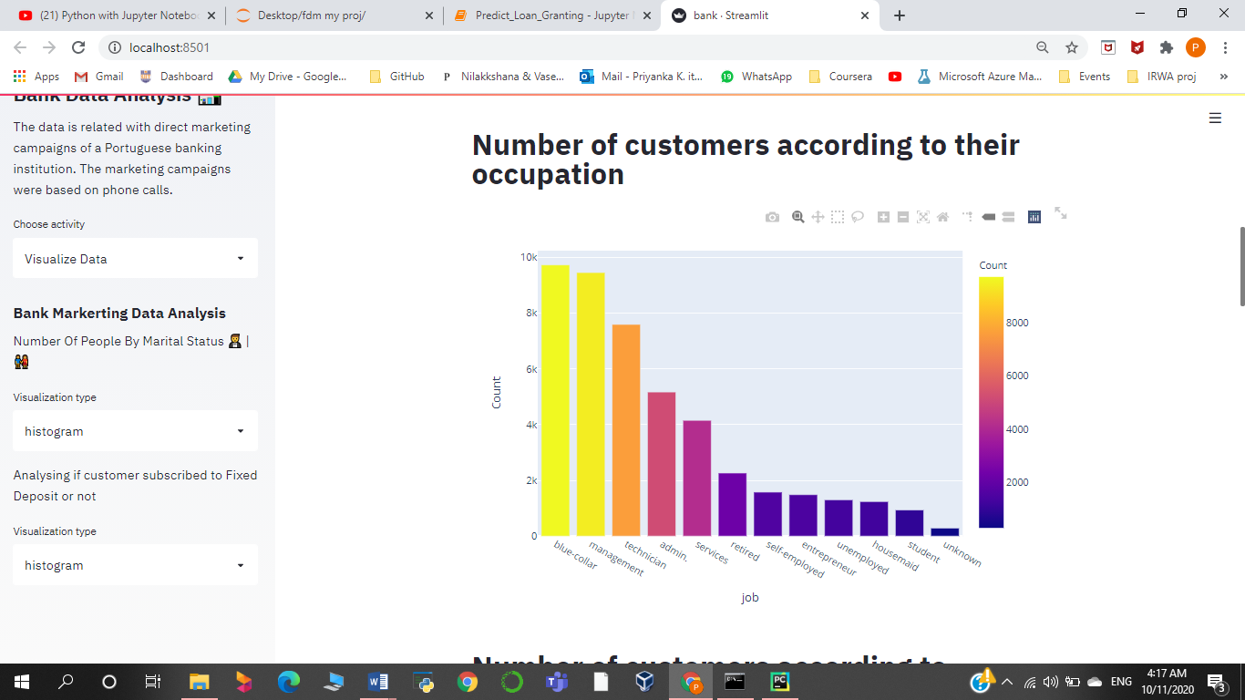

The above bar chart displays the number of customers of the bank respective to their occupation.

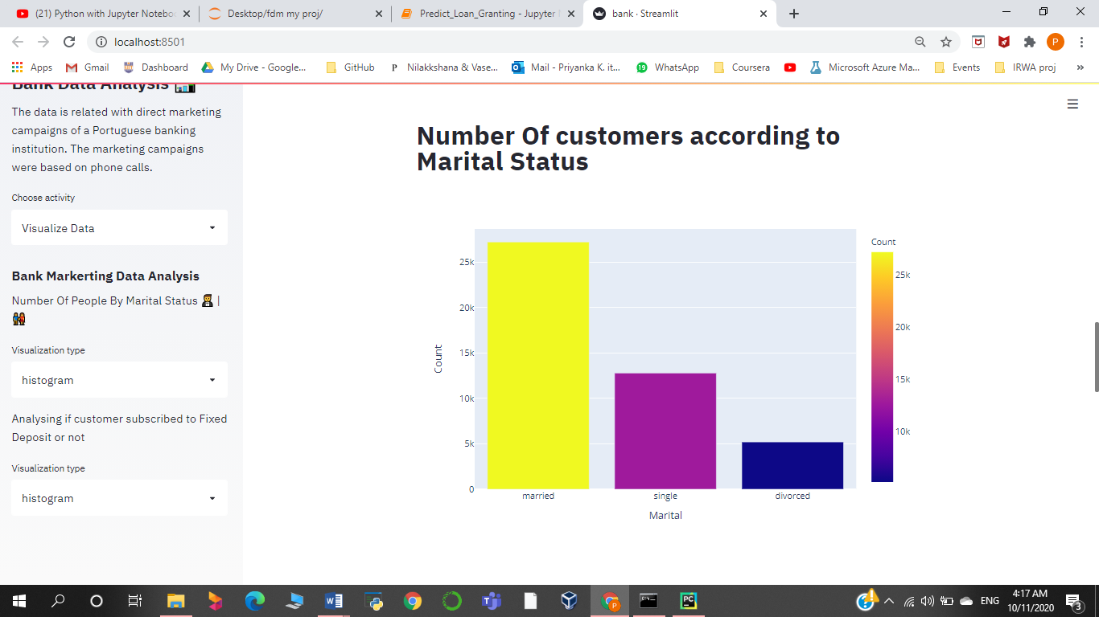

The above bar chart displays the number of customers of the bank respective to their marital status.

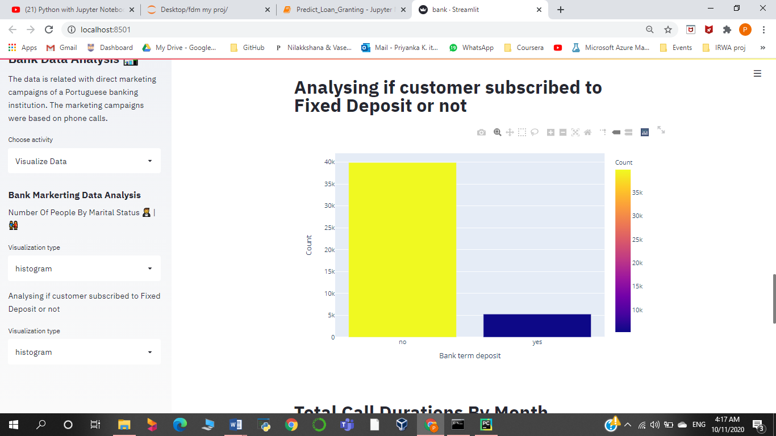

The above bar chart displays if a customer is subscribed to a fixed deposit account or not.

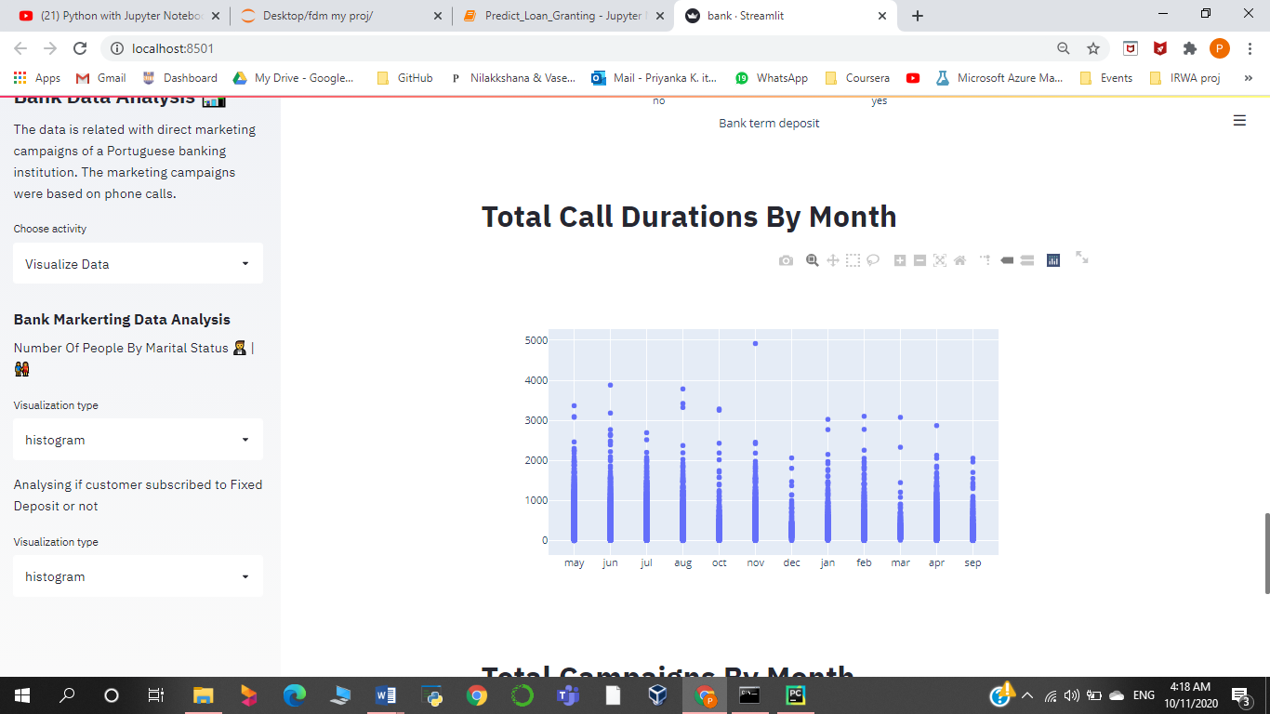

Looking at the above graph we can deduce that the longest call duration was recorded in the month of November.

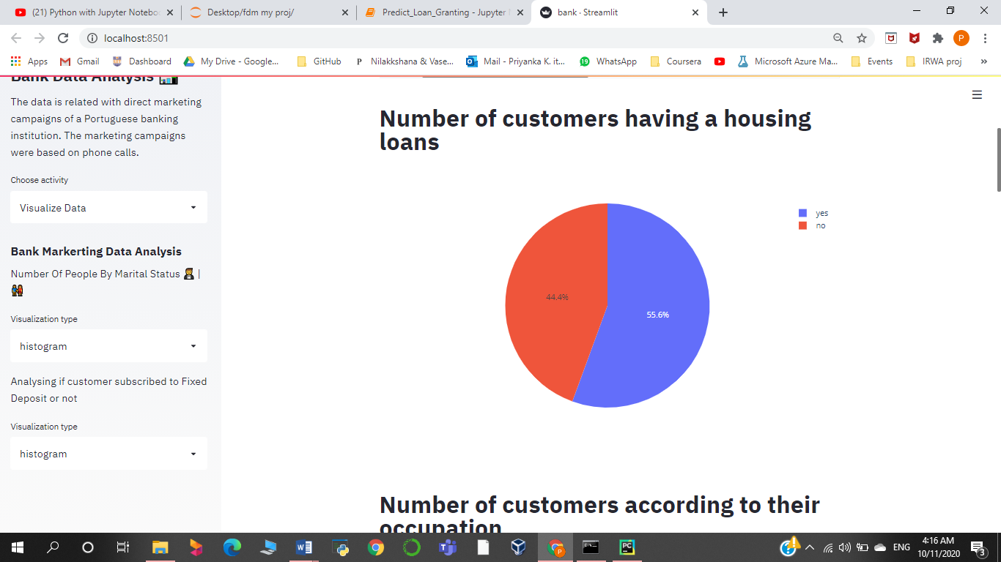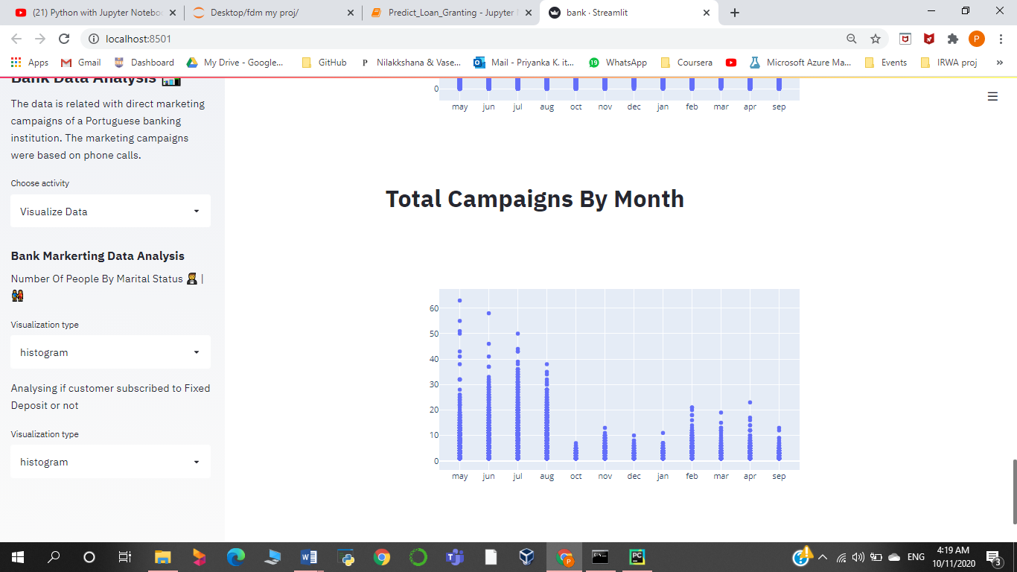Looking at the above graph we can deduce that the highest number of campaigns has taken place in the month of May.

Looking at the above pie chart we can deduce that around 60% of clients have subscribed to a housing loan.

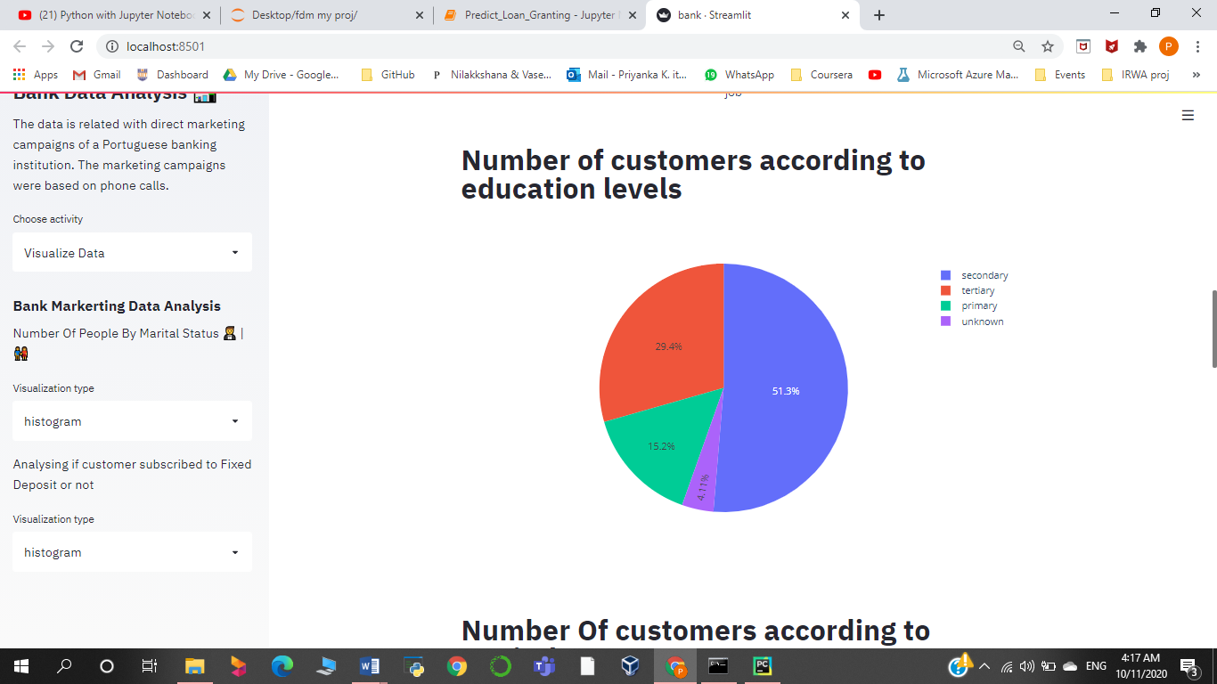

Looking at the above pie chart we can deduce that more than 50% of clients have completed their secondary education.

# Data Preparation

**•** The data set is partitioned into :

  Training set – 70% -  31,647 records

Testing set – 30% - 13, 563 records

# Data Preprocessing

## **Importing dataset & split dataset**

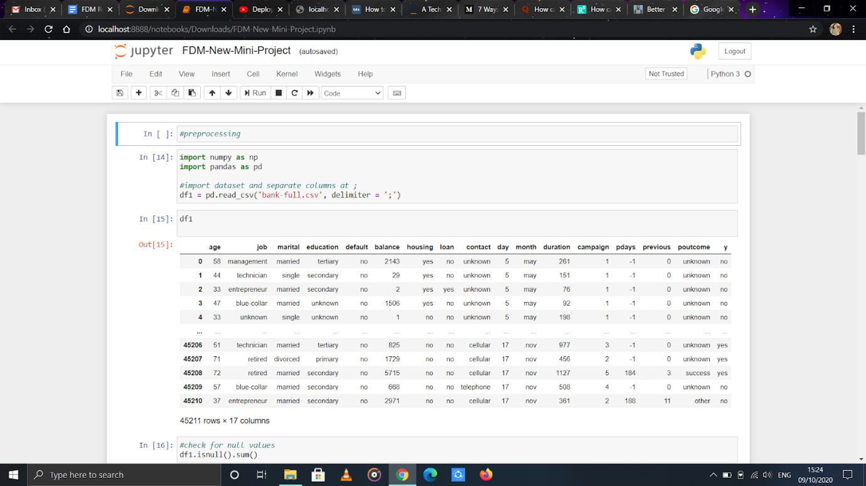

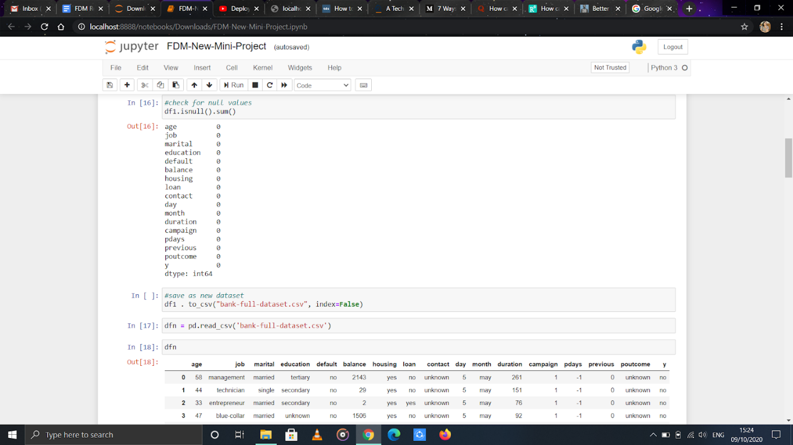

We drop columns that have too many unknown data

# **Prediction 01  -  Predict if Customer will make a fixed deposit or not**

·       **Description**

Predict if a client will create a fixed deposit or not. Prediction is done by using the ifCreatedAccount column.

**·       Analysing Classification Models**

Weused classification models and predicted the accuracies for them by using Azure machine Learning Studio. Chi squared method was used to select the best features for the model.

**Two-Class Boosted Decision Tree**

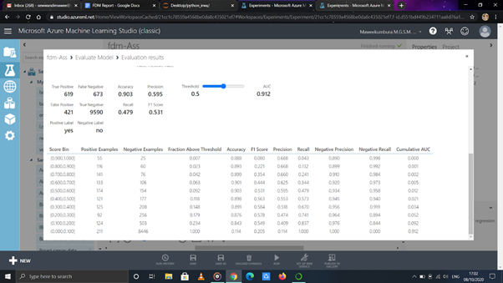

No of Features = 7

Accuracy = 0.903

**Two - Class Averaged Perceptron**

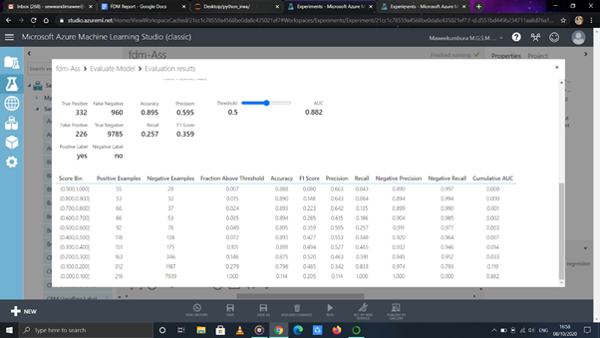

No of Features = 7

Accuracy = 0.895

**Two - Class Bayes Point Machine**

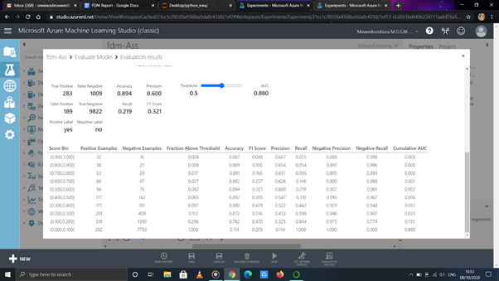

No of Features = 7

Accuracy = 0.894

**Two-class Decision Forest**

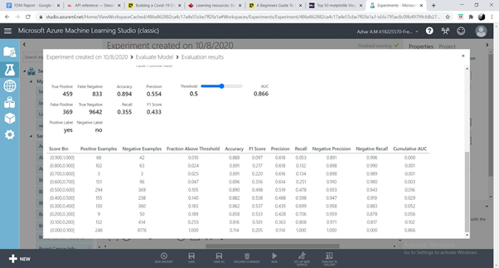

No of Features = 8

Accuracy = 0.894

**Two-class Decision Jungle**

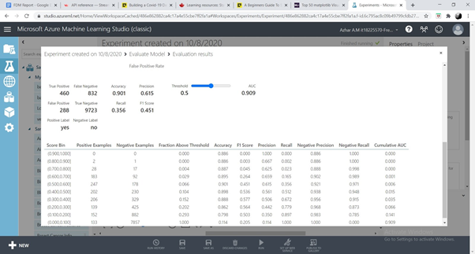

No of Features = 8

Accuracy = 0.901

**Two-class locally deep support vector machine**

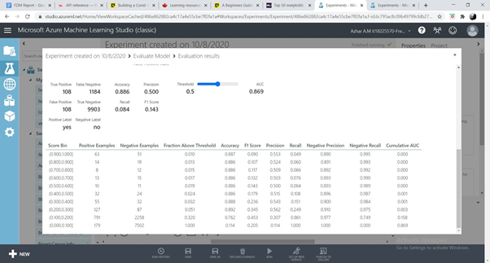

No of Features = 7

Accuracy = 0.886

**Two-class Logistic Regression**

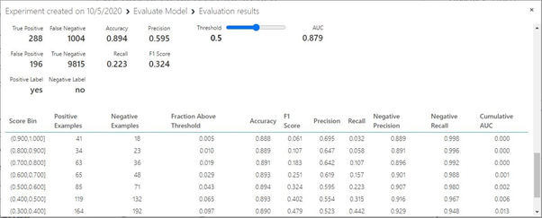

No of Features = 8

Accuracy     = 0.894

**Two-class Neural Network**

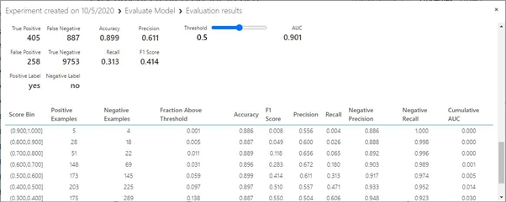

No of Features = 8

Accuracy    = 0.899

**Two-class Support Vector Machine**

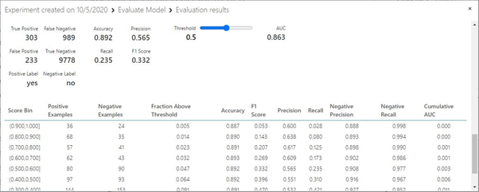

No of Features = 10

Accuracy    =0.892

After doing the analysis, it was concluded that the highest accuracy was obtained when 7 variables were used. They are :

Age, job, housing loan, month of contact, duration of call, pdays (last contacted days before) and if customer was previously contacted or not (previous)

## **·       Splitting the dataset and cleaning**

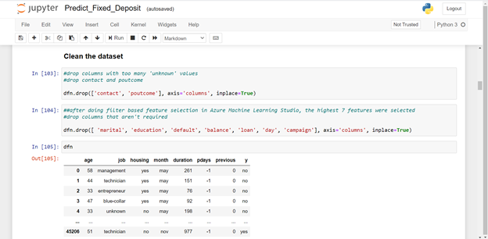

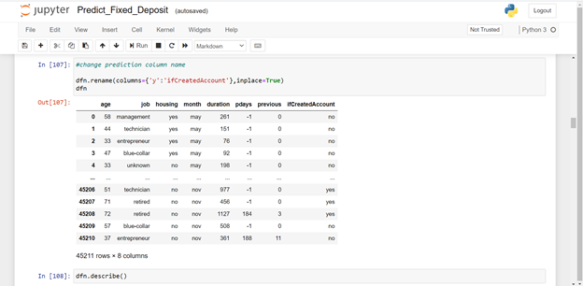

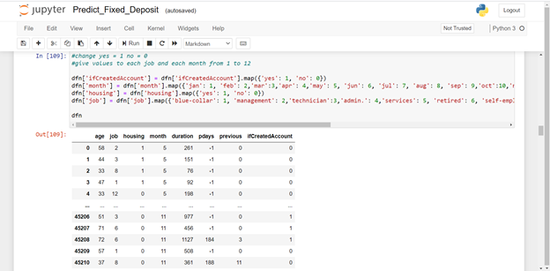

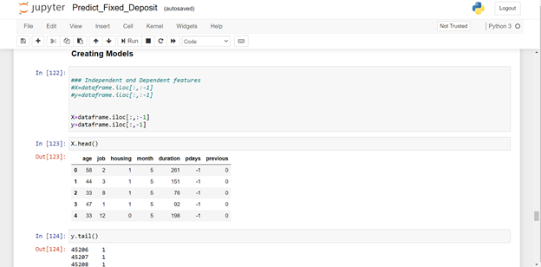

**Creating Models**

**Cleaned Dataset**

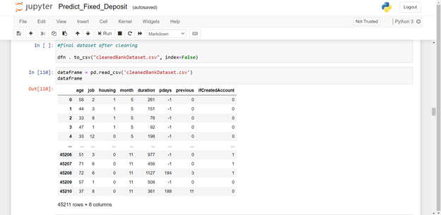

**Splitting data**

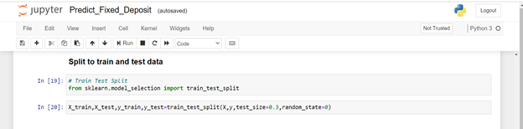

## **·       Models Accuracy**

**Random Forest Classifier**

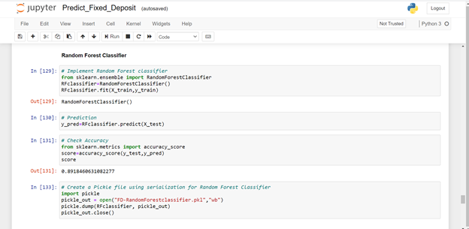

**Gaussian Naïve Bayes Classifier**

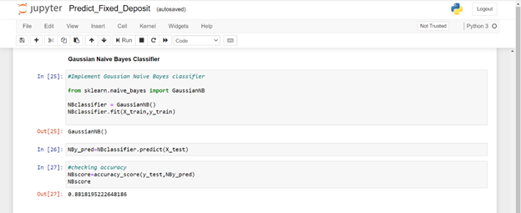

**Decision Tree Classifier**

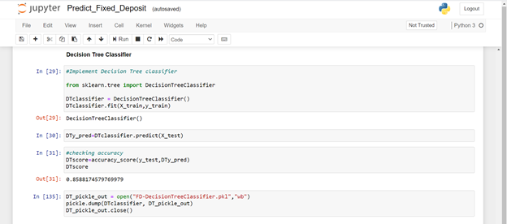

**KNN Classifier**

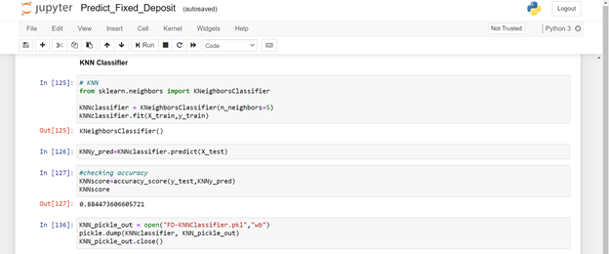

**·       Data-Graphs**

**Plot of the Created Account or not - Count**

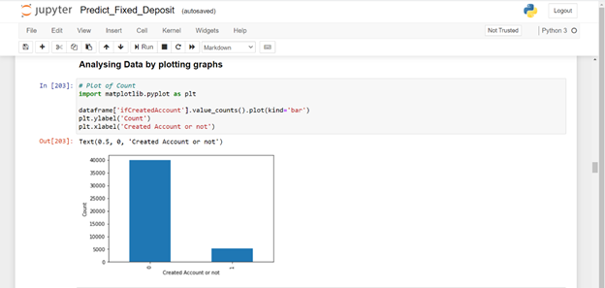

**Scatterplot**

**Compare the ages of customers who took fixed deposit and who didn’t**

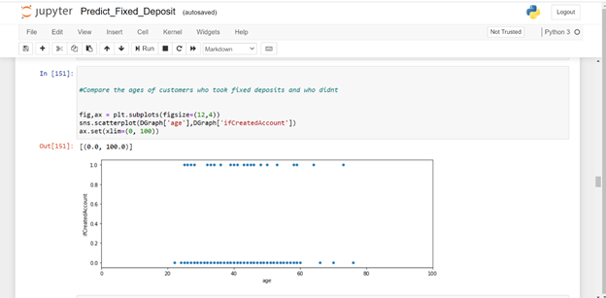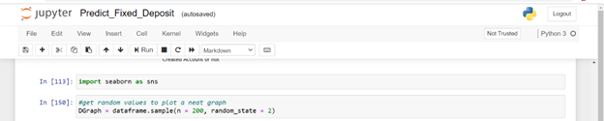

**Compare the duration of customers who took fixed deposit and who didn’t**

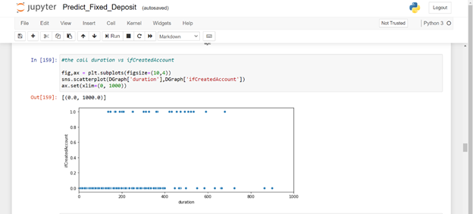

**Compare age month of last call with ifCreatedAccount**

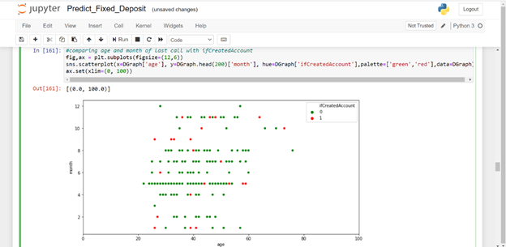

**Bar-Graphs**

**Comparing job with the ifCreatedAccount column**

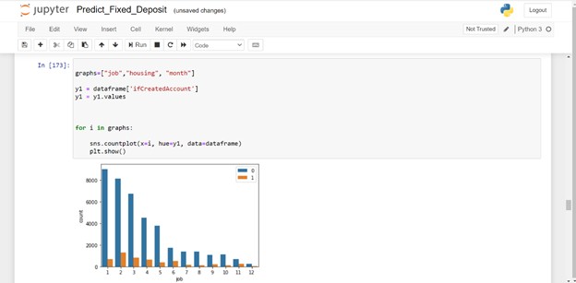

**Comparing housing  with the ifCreatedAccount column**

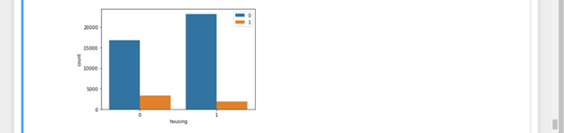

**Comparing month  with the ifCreatedAccount column**

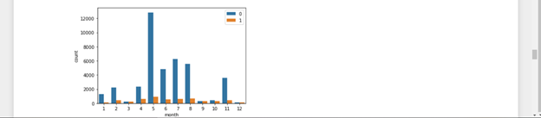

## **Conclusions:**

+ more customers who had didn’t have housing loans have fixed deposits

+ the month of May is a better time to approach customers regarding fixed deposits

+ more customers working in the management sector has taken fixed deposits

# **Prediction 2 : Predict if customer should be granted a loan or not**

## **Description**:

Predict if a client should be granted a loan or notby checking whether a customer has failed to fulfil a loan (pending credit) or not. We use the default column, which tells us if the customer has a pending credit or not. The column has been renamed to ifCreditExists, for a higher understandability.

**Analysing Classification Models**

**Two Class Decision Forest**

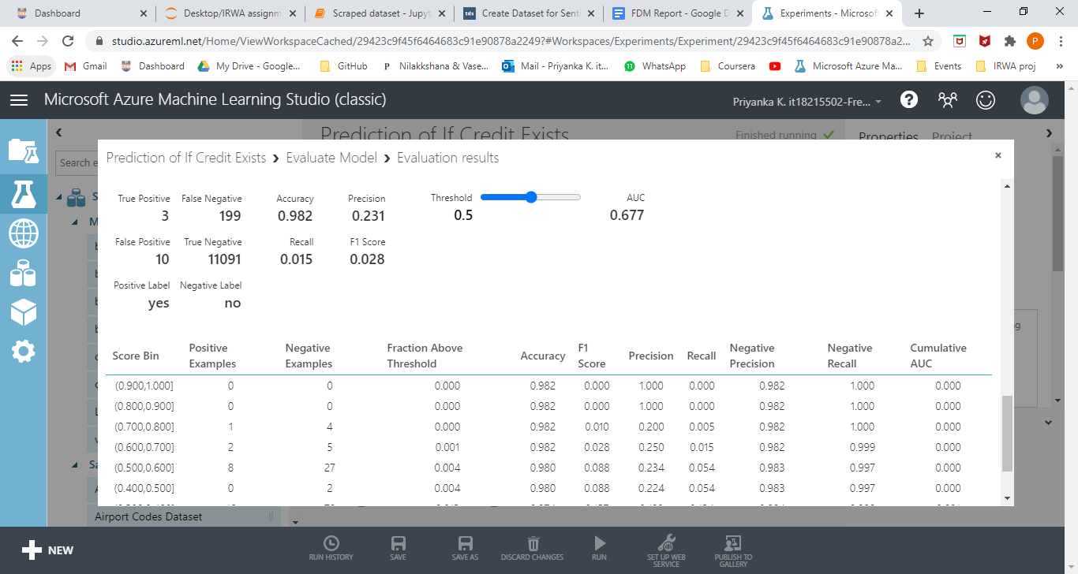

No of Features = 10

Accuracy =0.982

**Two Class Neural Network**

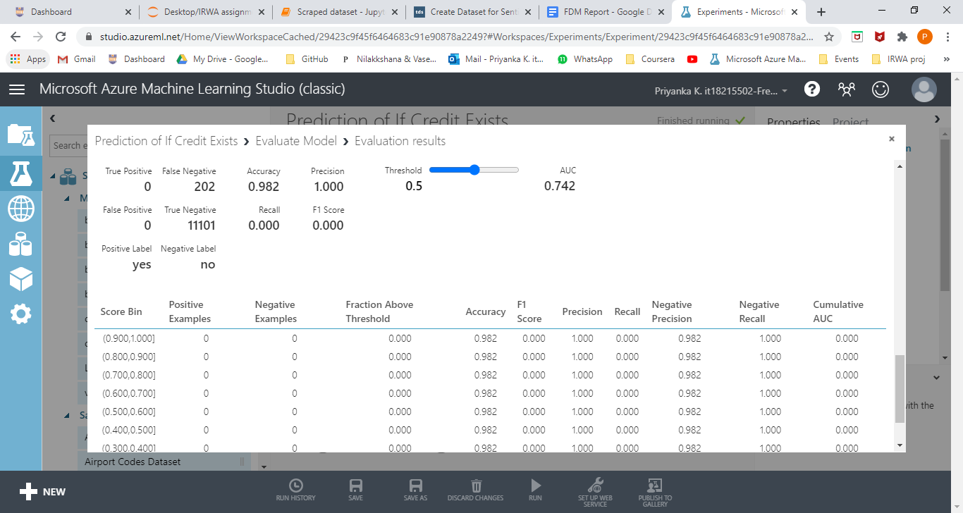

No of Features = 7

Accuracy = 0.982

**Two Class Support Vector Machine**

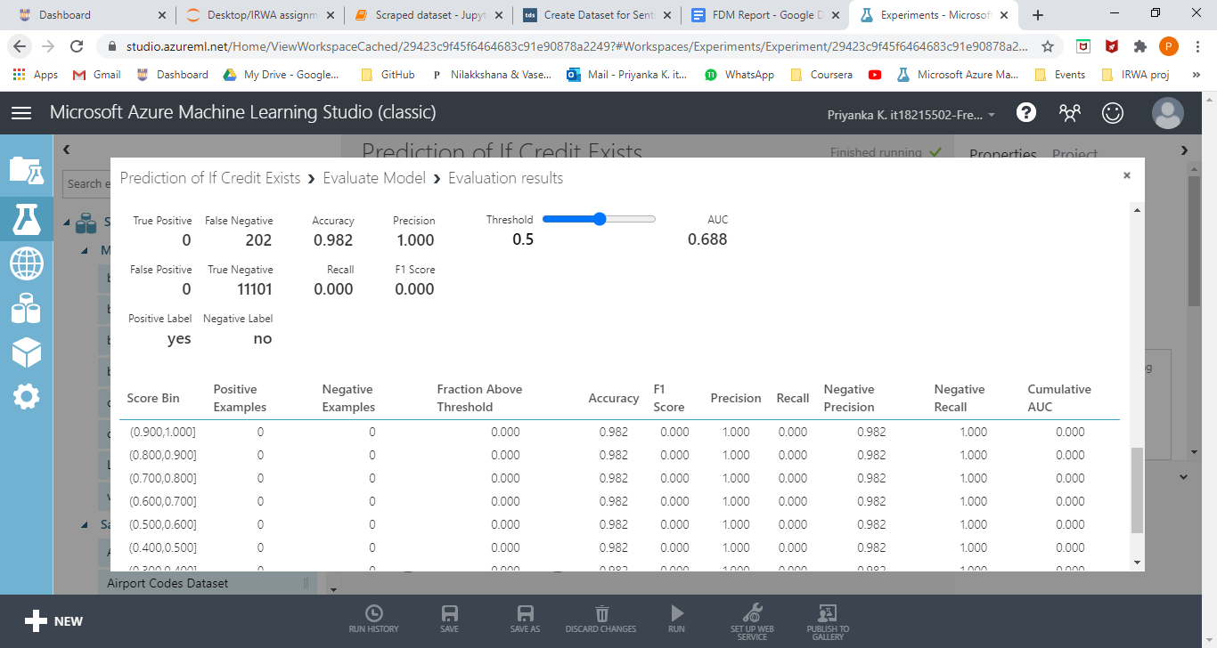

No of Features = 7

Accuracy = 0.982

**Two Class Boosted Decision Tree**

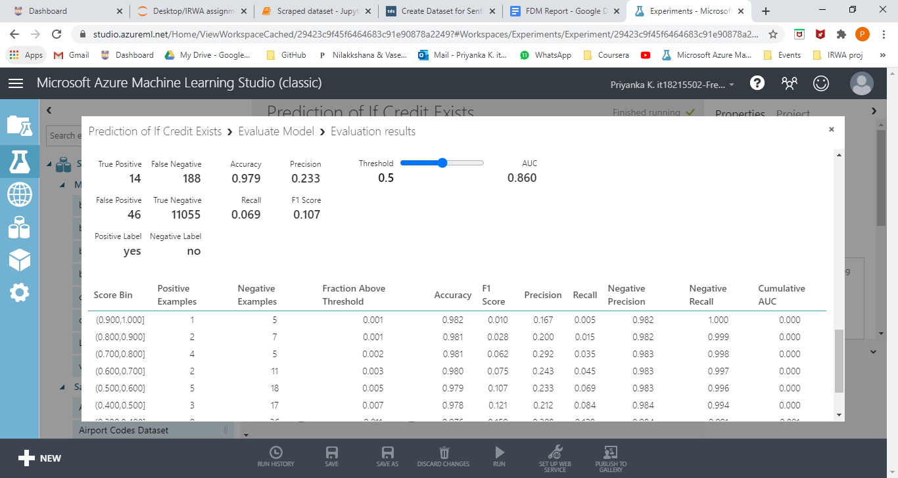

No of Features = 10

Accuracy = 0.979

After doing the analysis, it was concluded that the highest accuracy was obtained when 8 variables were used. They are :

Age, job, balance of savings account, personal loan, day of contact, month of contact, duration of call, pdays (last contacted days before) and if customer was previously contacted or not (previous) and if they have a Fixed deposit or not.

## **Splitting the dataset and cleaning**

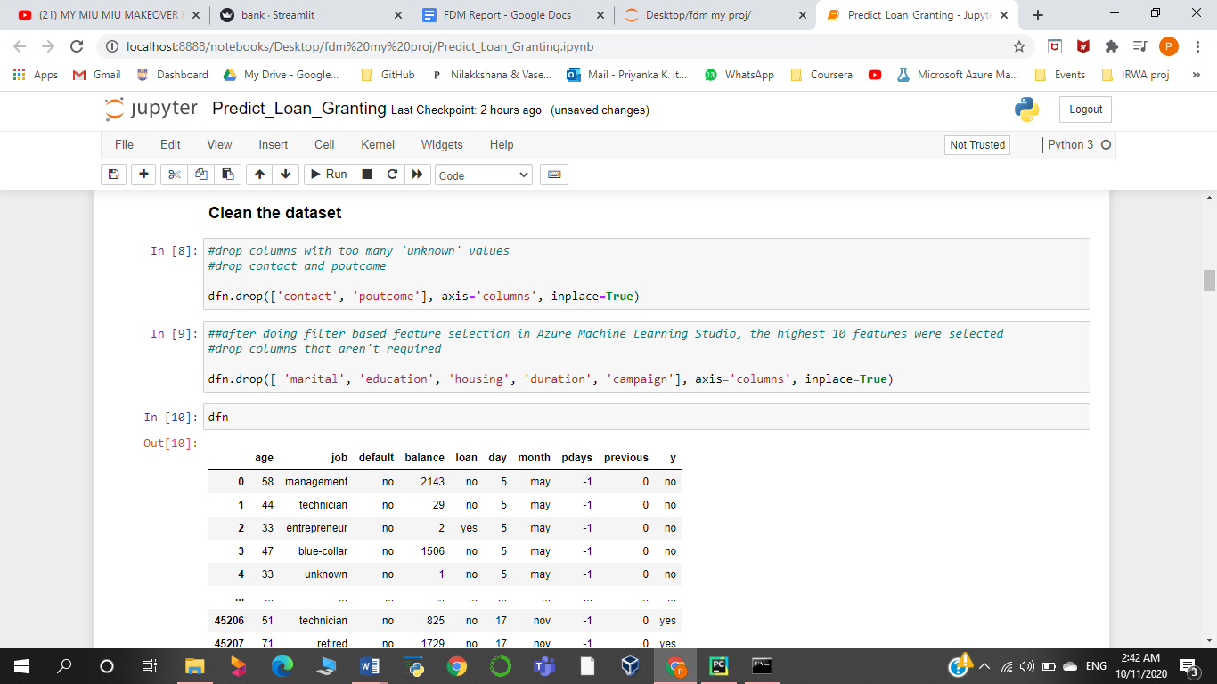

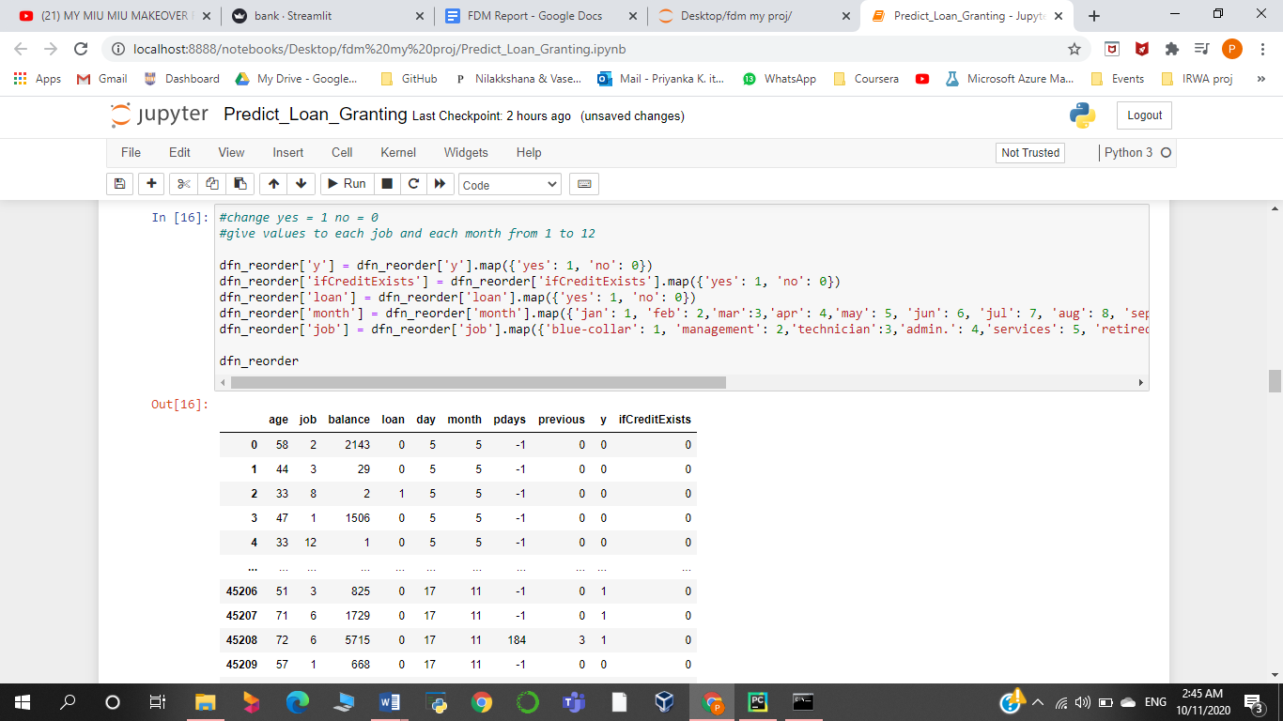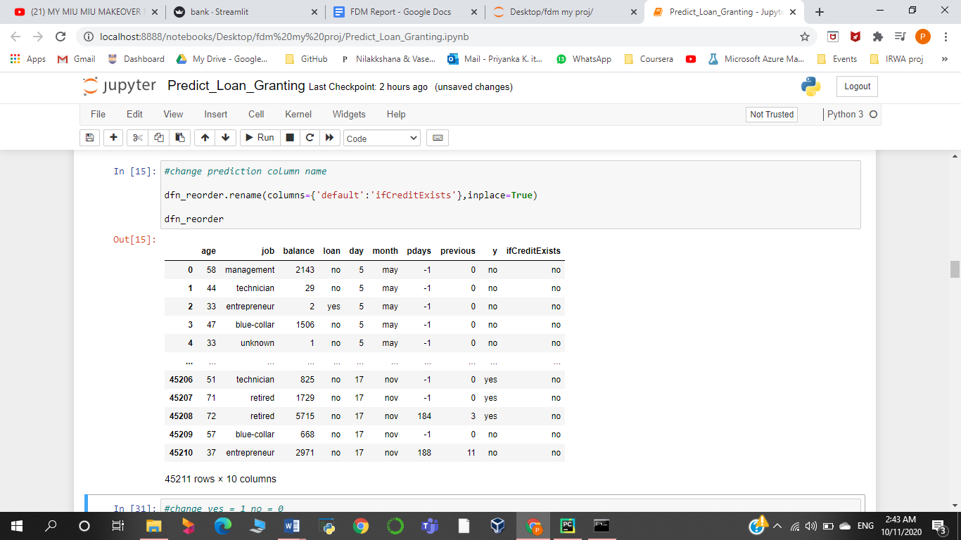

**Cleaned dataset**

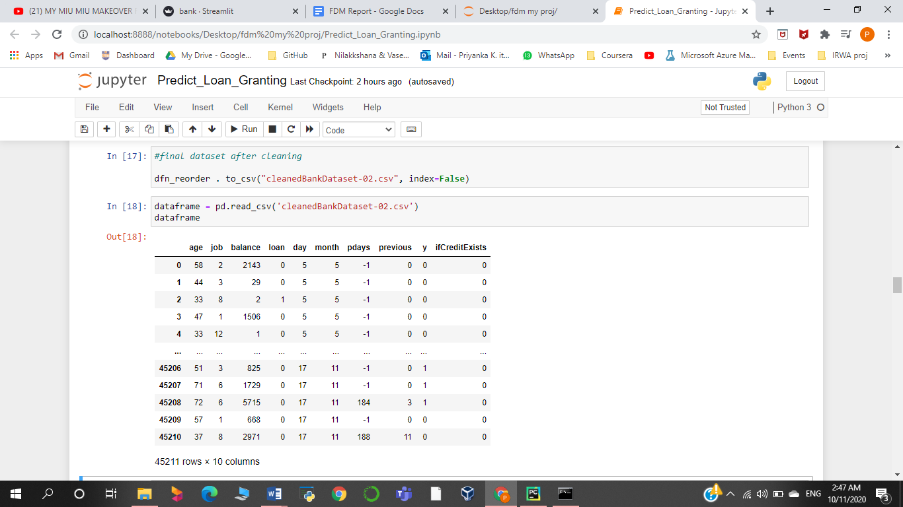

## **Creating models**

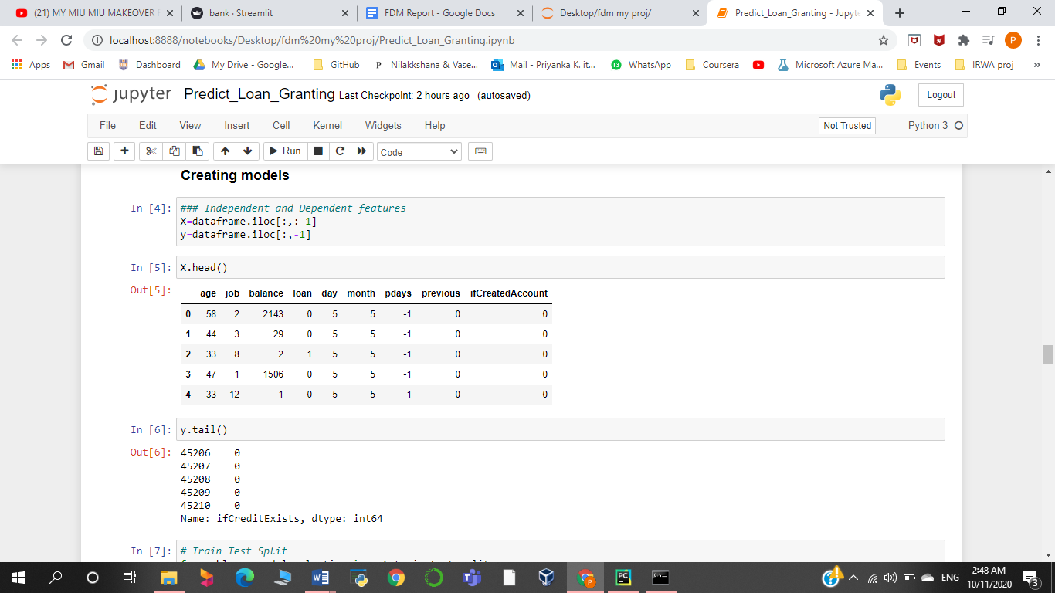

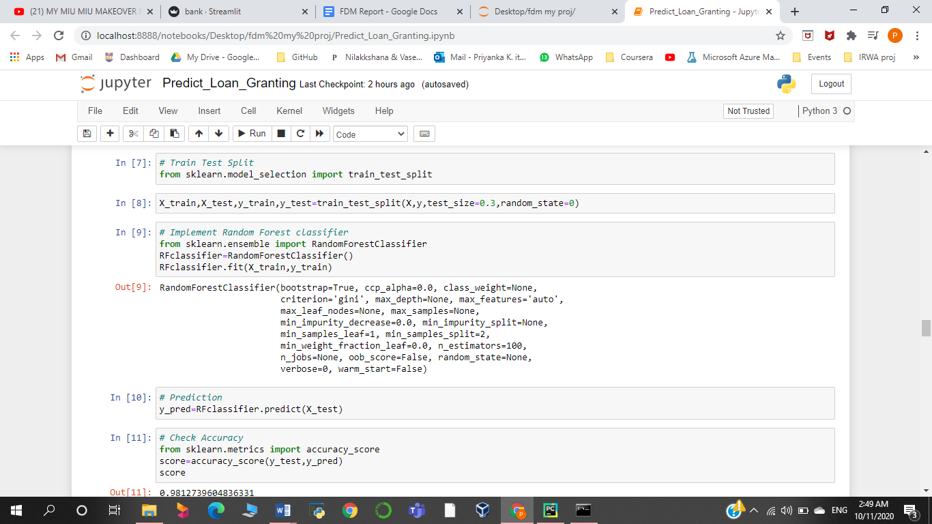

## Models Accuracy

**Random Forest Classifier**

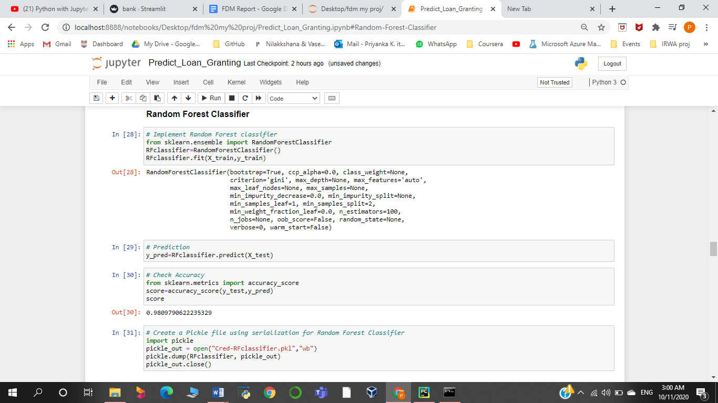

**Gaussian Naïve Bayes Classifier**

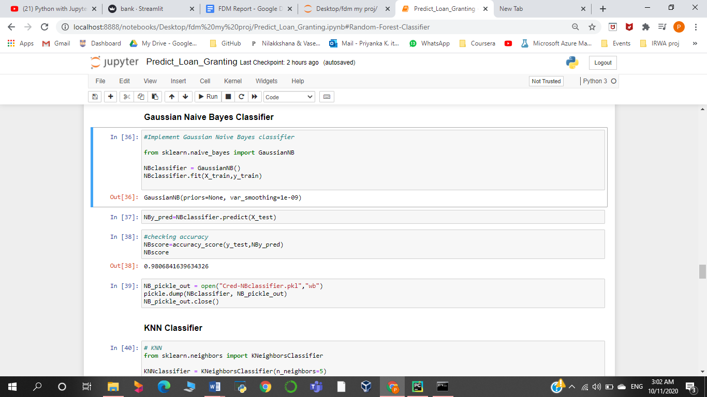

**Decision Tree Classifier**

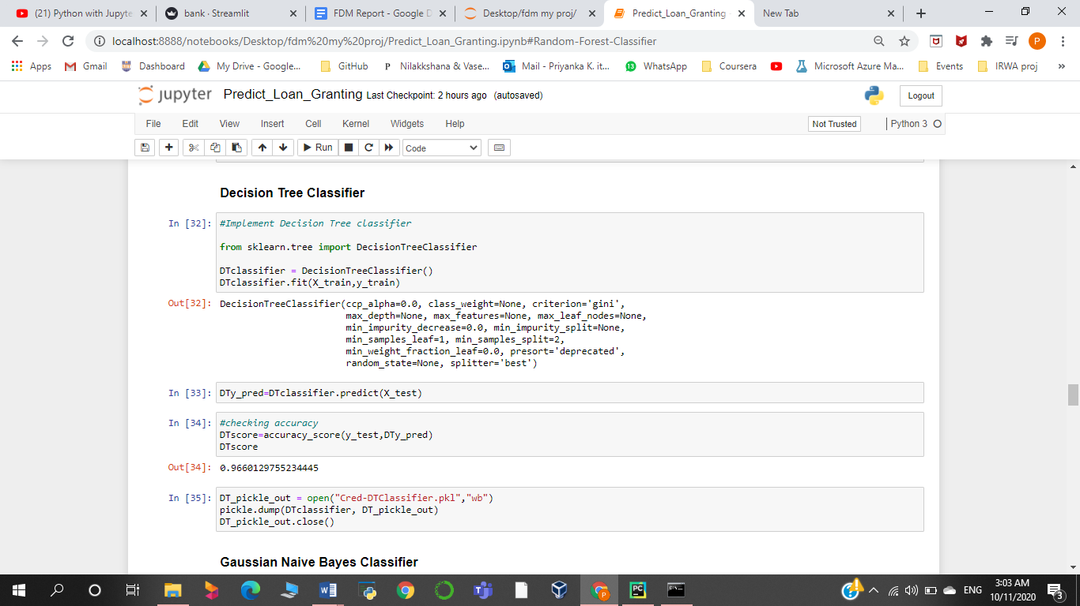

**KNN Classifier**

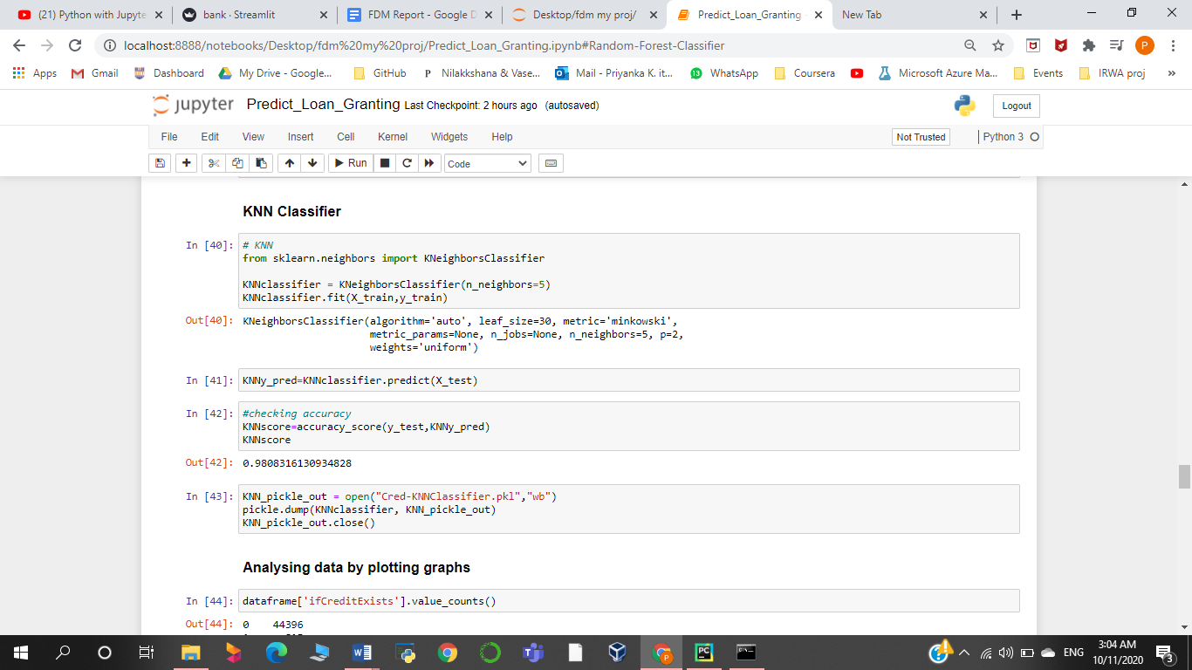

## Data-Graphs

**Plot of the Credit Exists or not – Count**

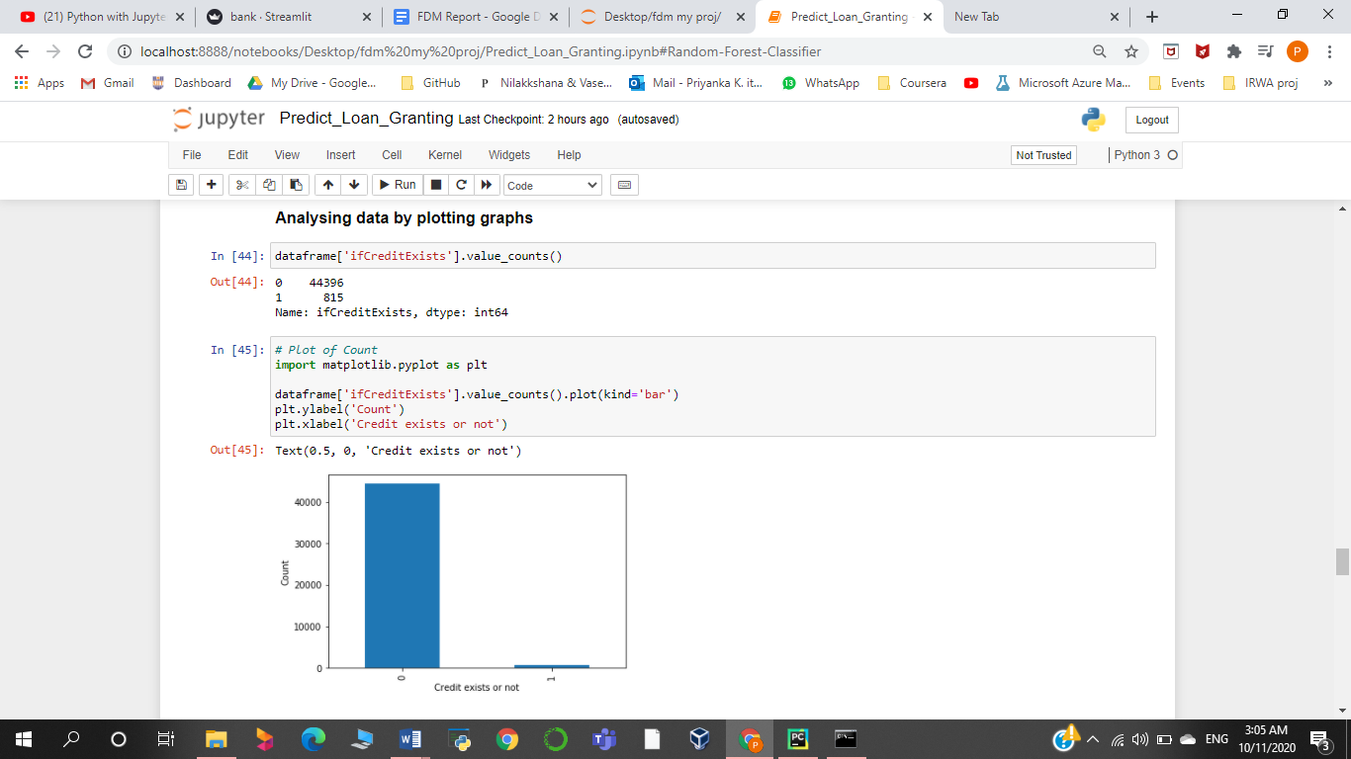

**Scatterplot**

**Comparing the balance of the clients who have existing credit**

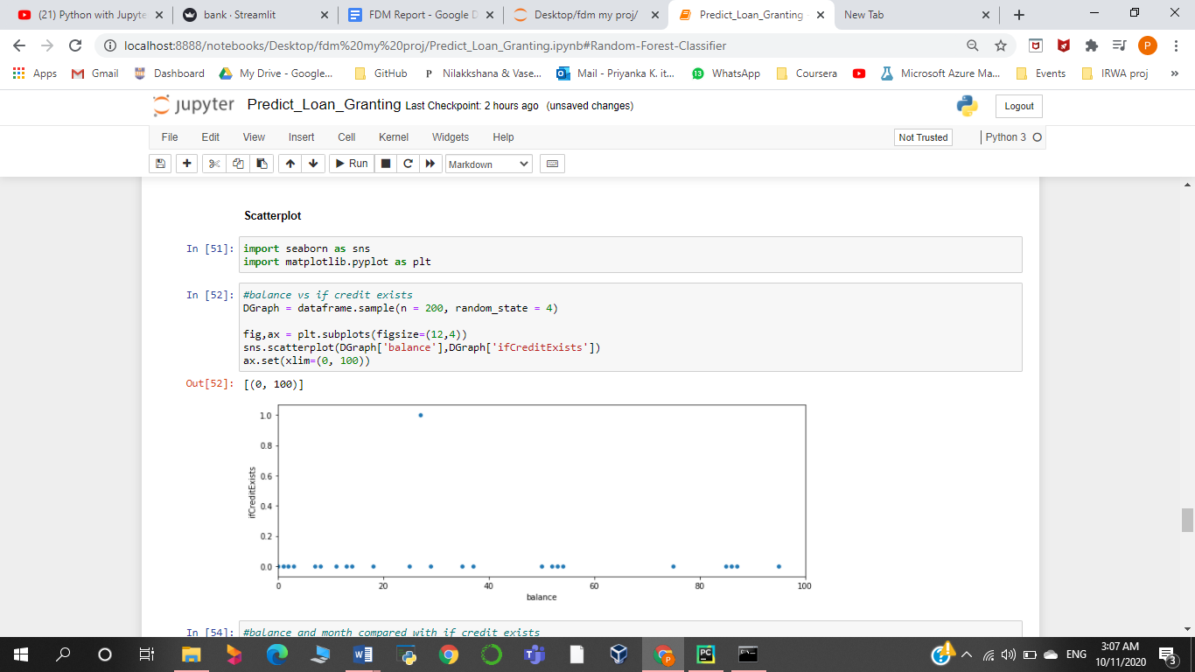

**Comparing the balance and month with clients who have existing credit**

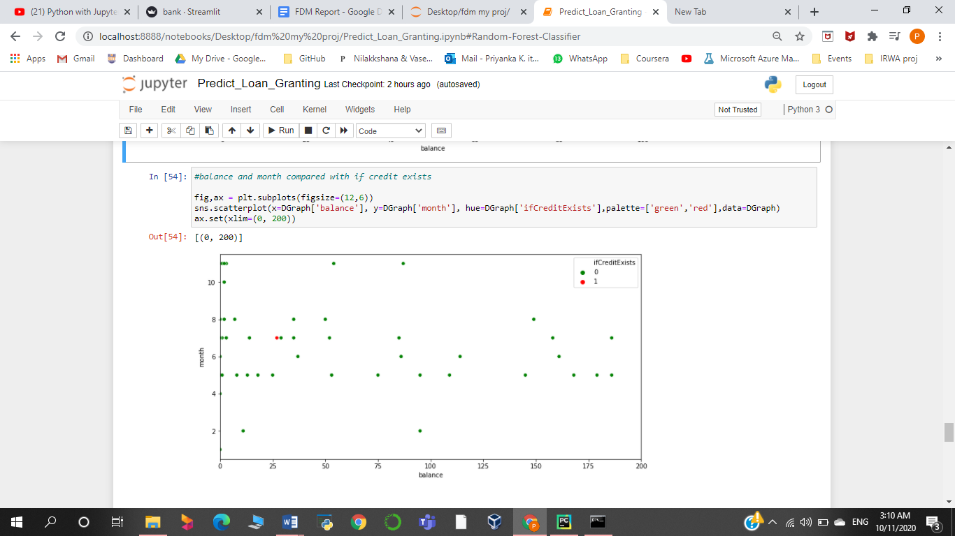

**Bar-Graphs**

**Comparing job with the ifCreditExists column**

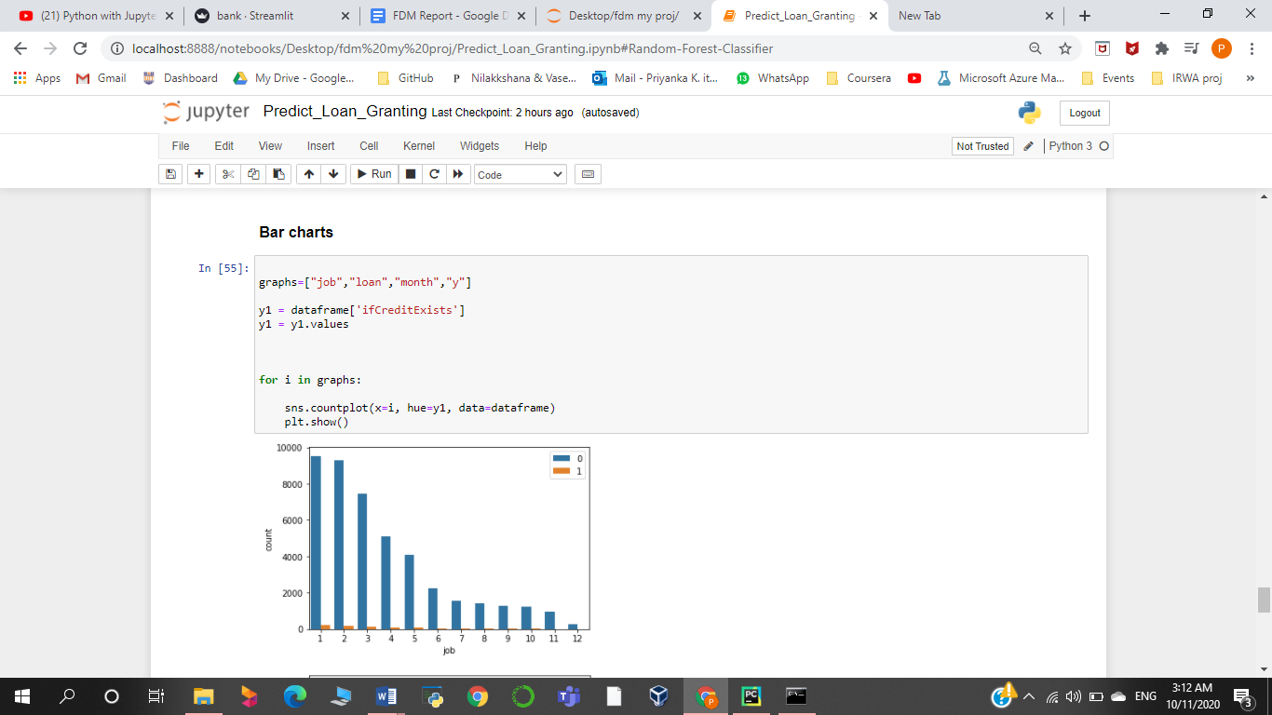

**Comparing loan with the ifCreditExists column**

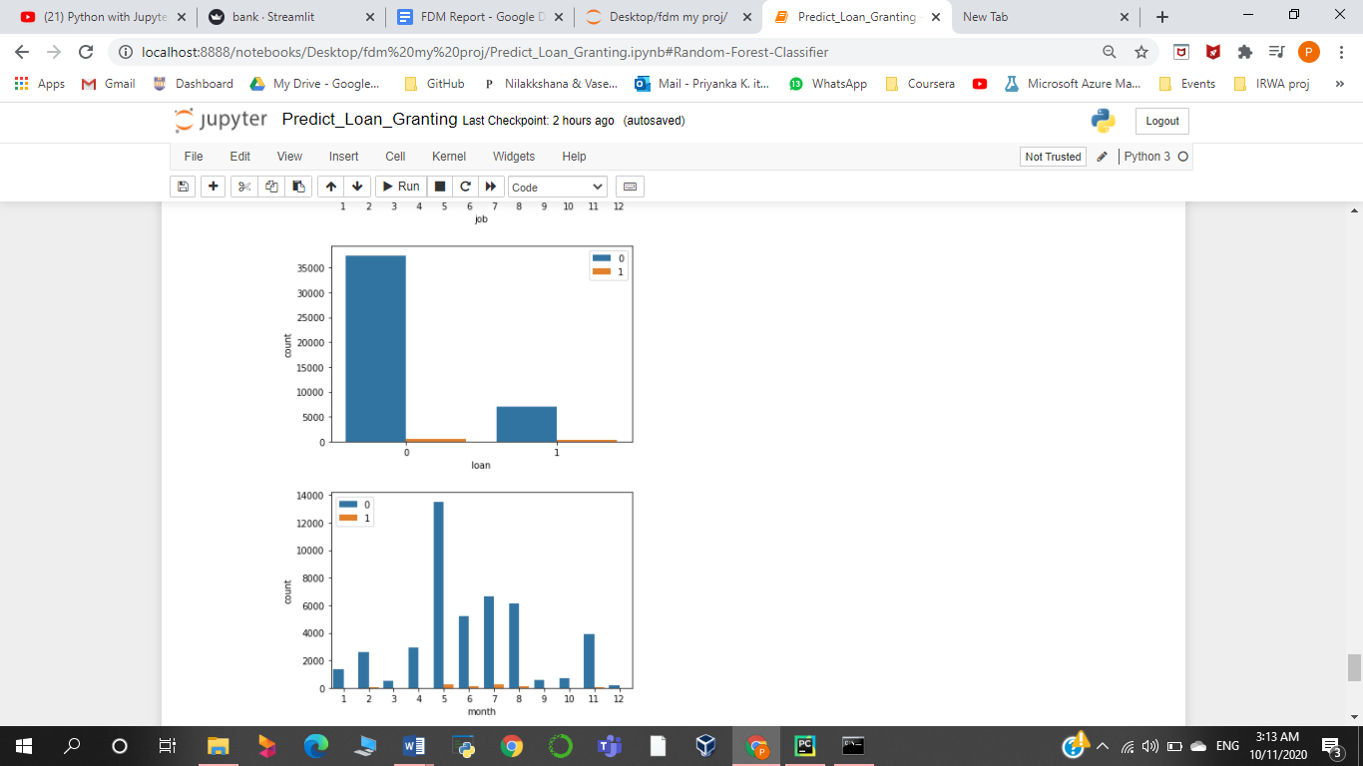

**Comparing month with the ifCreditExists column**

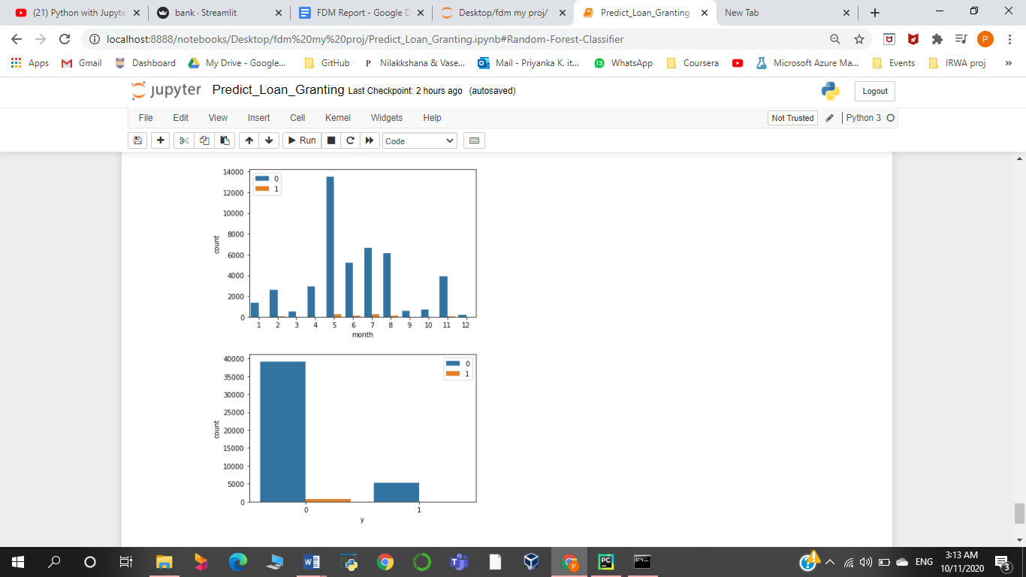

**Comparing y with the ifCreditExists column**

(here y is if the client has subscribed to a term deposit or not)

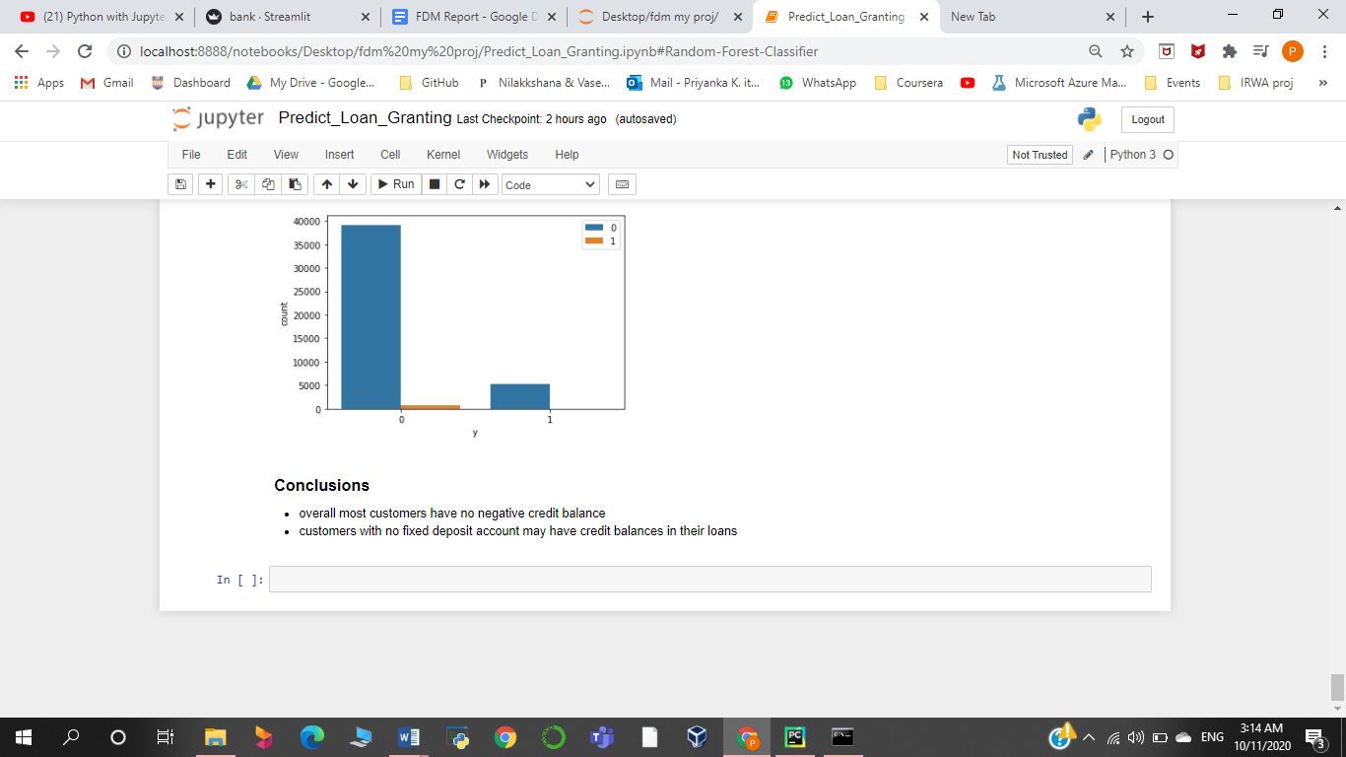

## Conclusions:

+ overall most customers have no negative credit balance

+ customers with no fixed deposit account may have credit balances in their loans

# **Prediction 03 -  Predict if Customer may take a Housing loan or not**

**Description**

Using Chi Squared Method as the Filter Based Selection method to get the best and highest accuracy, we predict if the customer may take a housing loan or not.

**Two-Class Boosted Decision Tree**

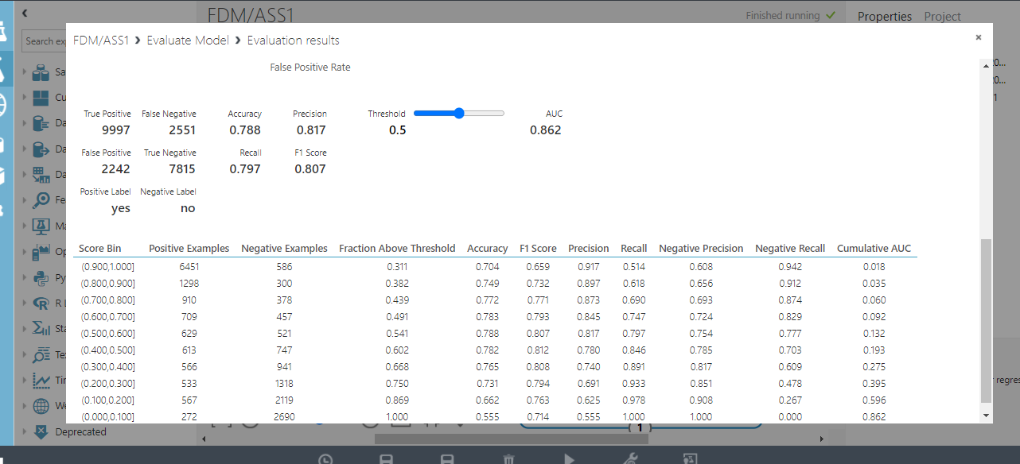

No of Features = 7

Accuracy =0.788

**Two-class Decision Forest**

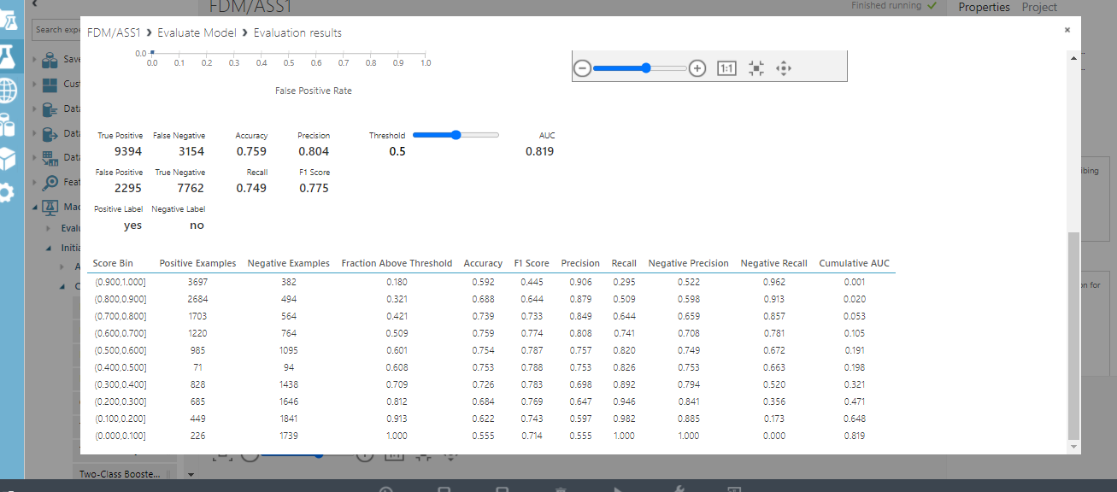

No of Features = 6

Accuracy =0.759

**Two-class Support Vector Machine**

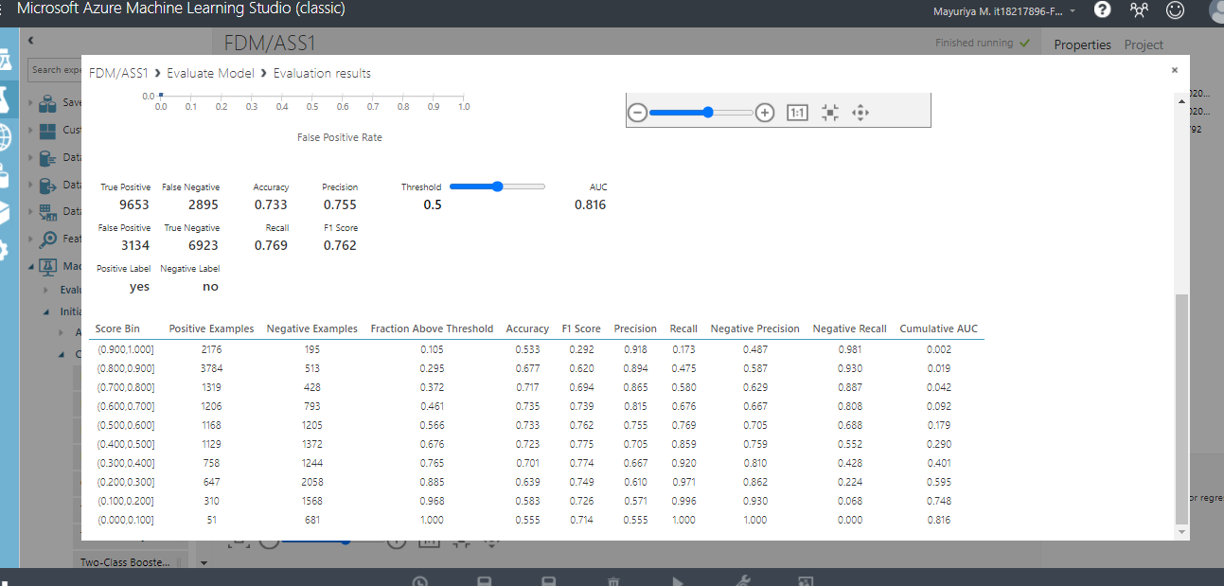

No of Features = 7

Accuracy =0.733

**Two-class Neural Network**

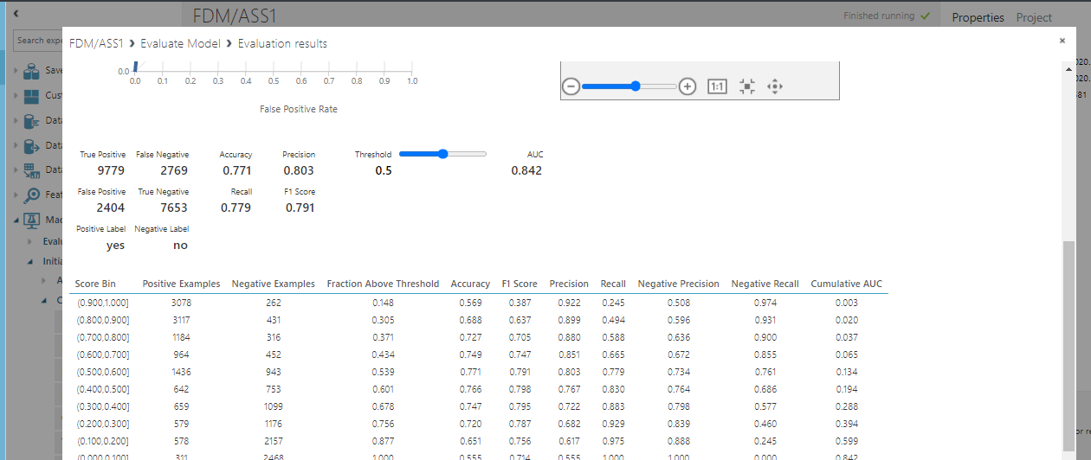

No of Features = 8

Accuracy =0.771

After doing the analysis, it was concluded that the highest accuracy was obtained when 7 variables were used. They are :

Age, Job, month, education, pdays, if Created Account, balance in savings account

## Splitting the dataset and cleaning

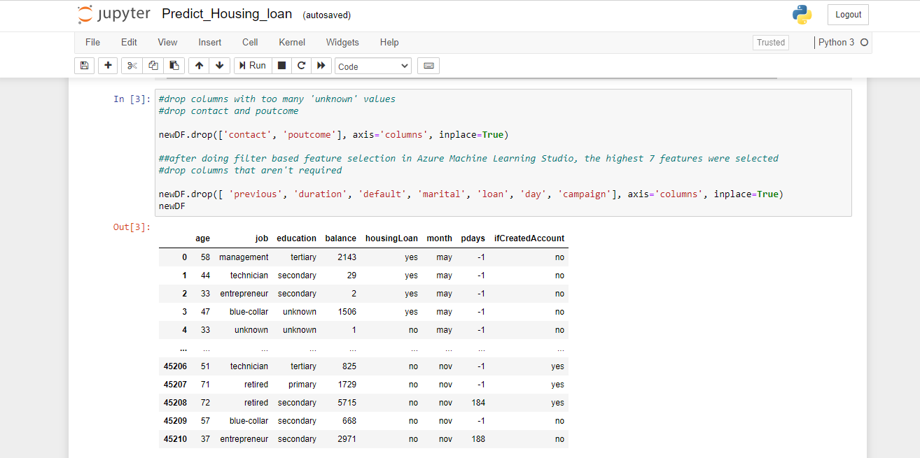

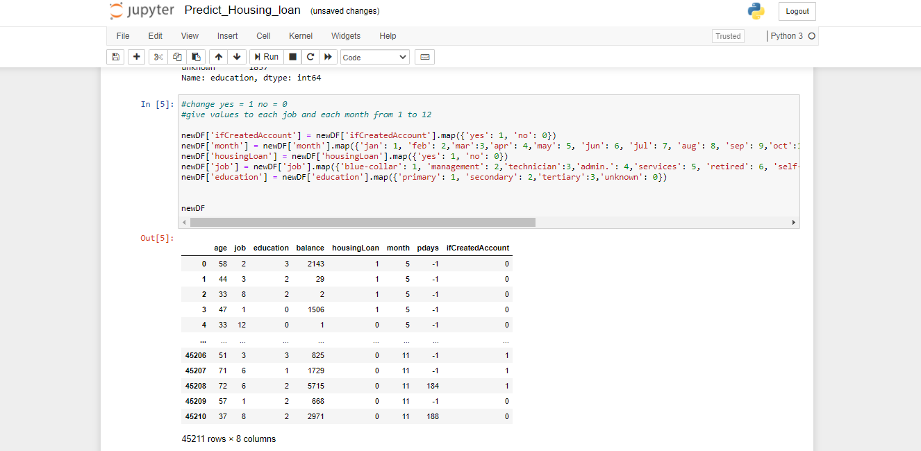

**Cleaning data**

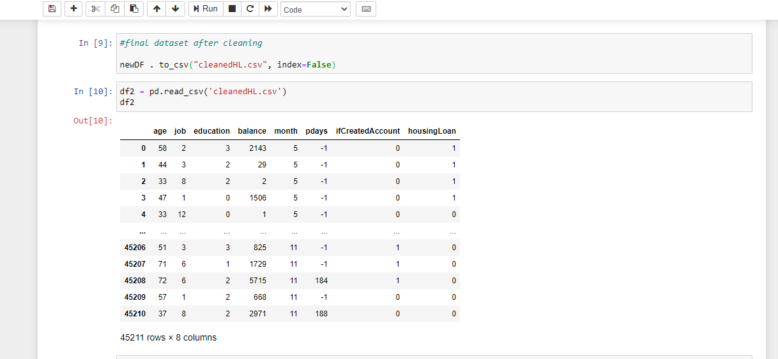

**Splitting data**

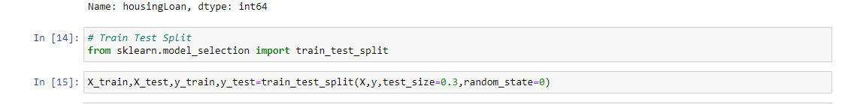

## Creating models

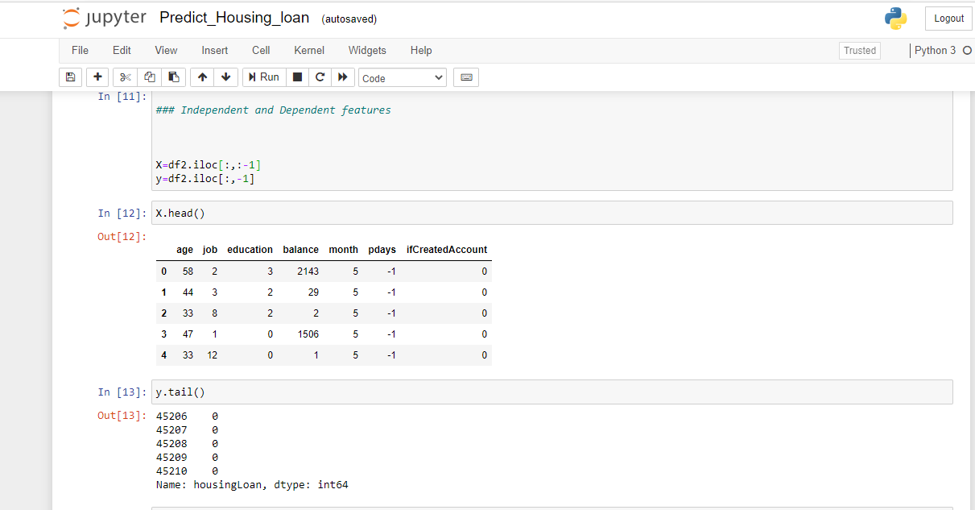

## ·       Models Accuracy

**Random Forest Classifier**

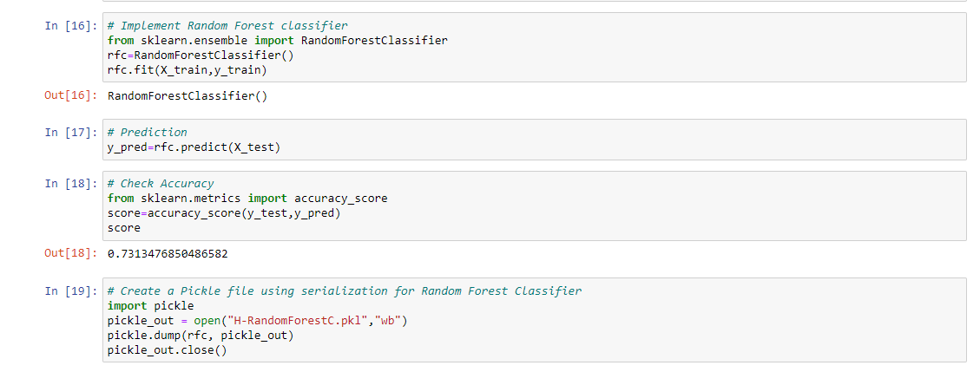

**Gaussian Naïve Bayes Classifier**

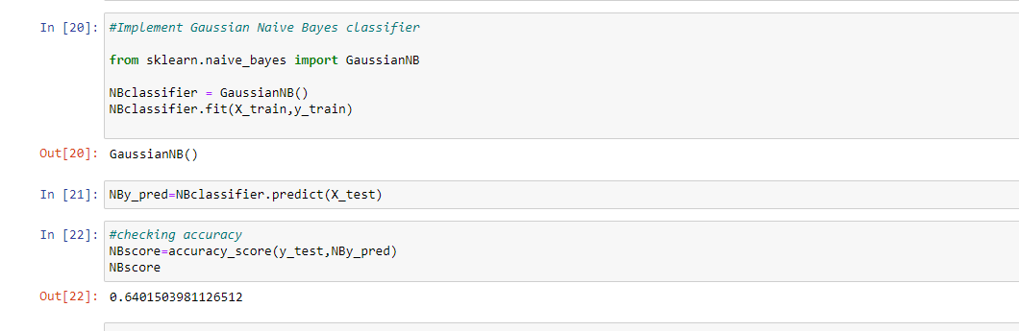

**Decision Tree Classifier**

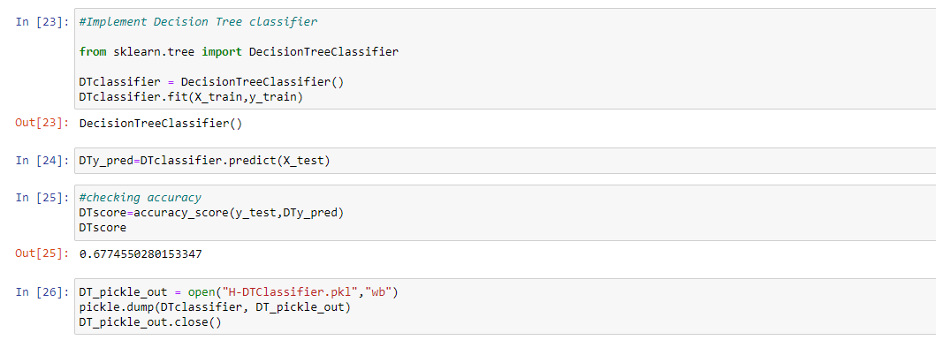

**KNN Classifier**

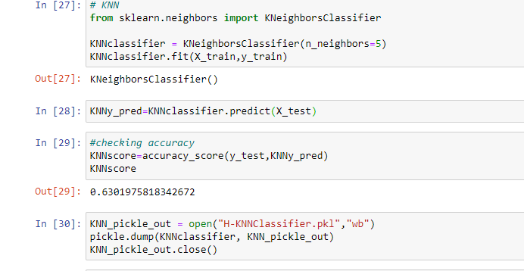

## Data-Graphs

**Plot of the customer will take housing loan**

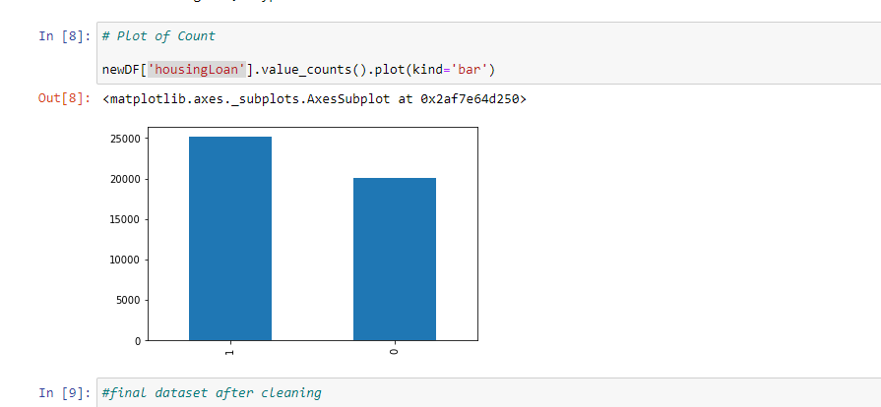

**Scatterplot**

**Comparing the Balance and Housing Loan**

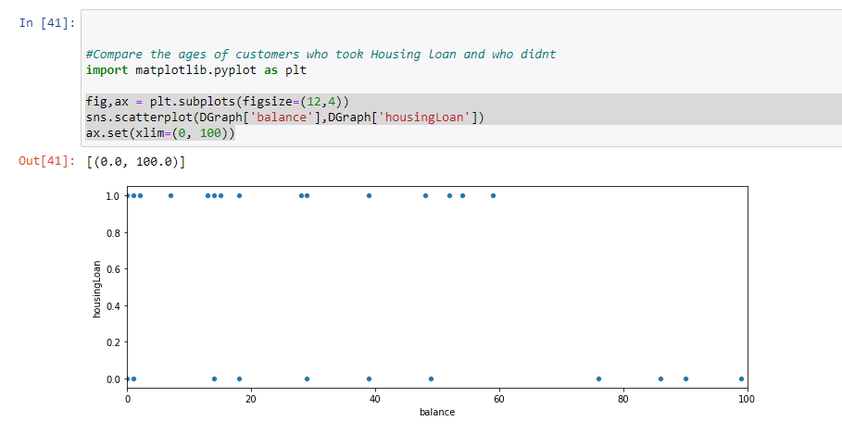

**clients who have get Housing loan compare with age**

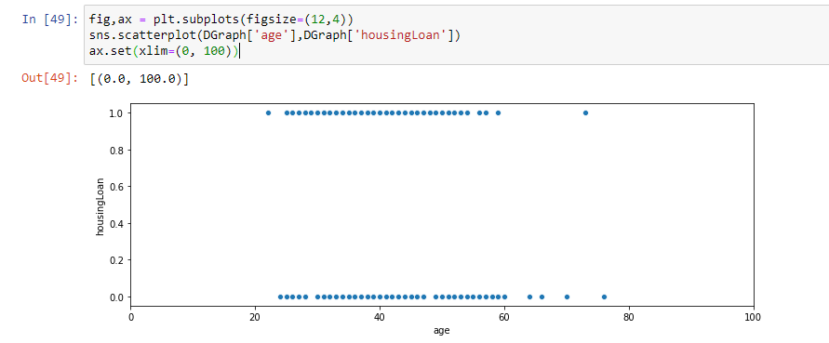

**Clients who will get Housing Loan compared with education**

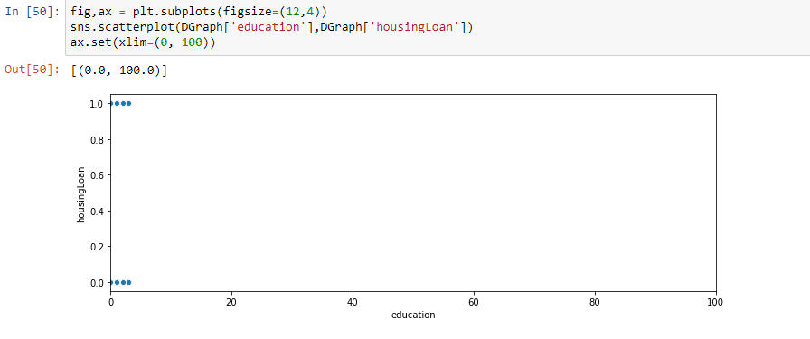

**Comparing age and month of who get Housing loan**

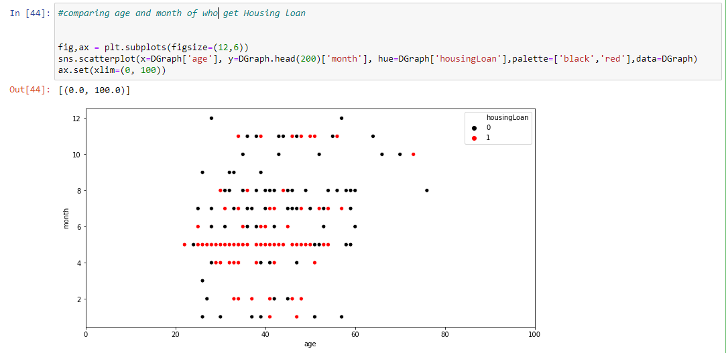

**Bar-Graphs**

**Comparing job with the HousingLoan column**

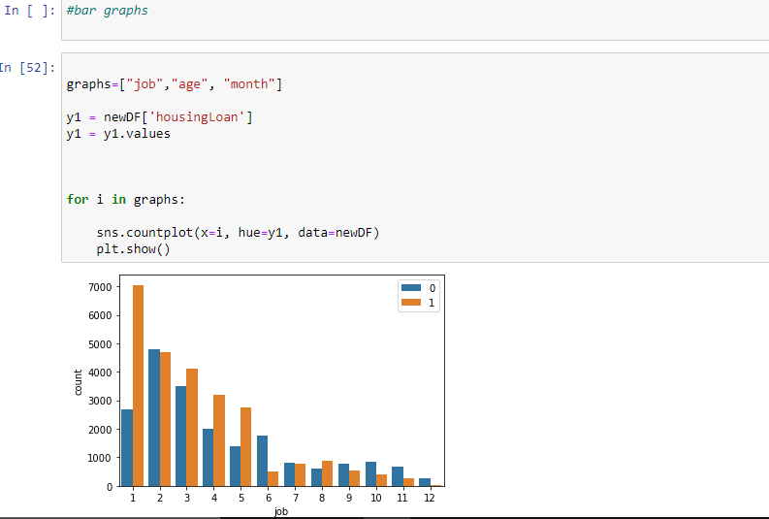

**Comparing Education with the ifgetHousingLoan column**

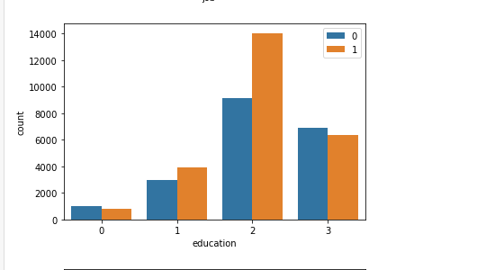

**Comparing month with the ifgetHousingLoan column**

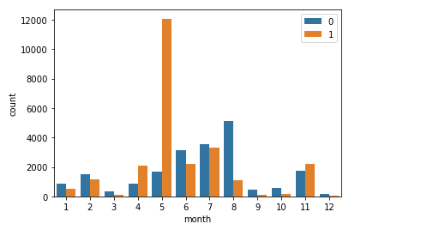

## Conclusions:

+ many with blue collar jobs have taken housing loans

+ many with a secondary education have taken housing loans compared to others

+ most who were contacted in the month of may have taken housing loans

+ most who have taken housing loans don’t have a fixed deposit account

# **Prediction 04 -  Predict if Customer will take a Personal Loan Or Not**

Predict if a client will take a personal loan or not. We use Chi Squared Method as the Filter Based Feature Selection Method**.**

## Analysing Classification Models

**Two-Class Boosted Decision Tree**

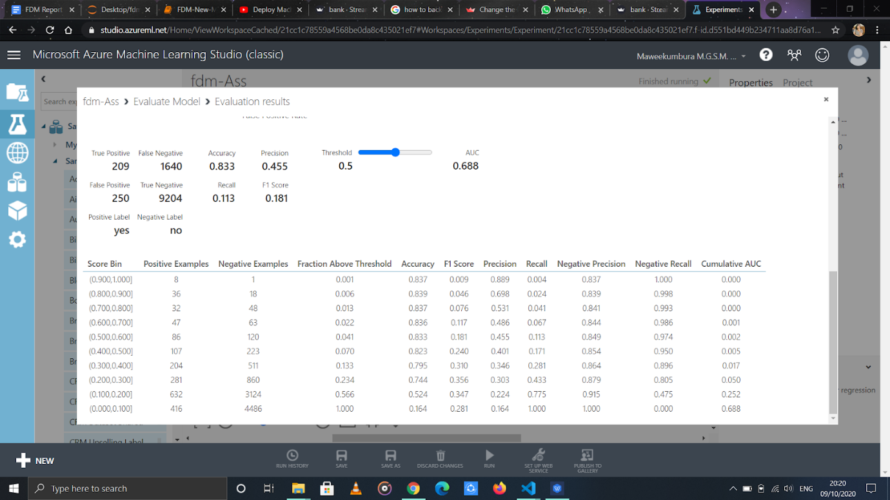

No of Features = 7

Accuracy =0.833

**Two-class Decision Forest**

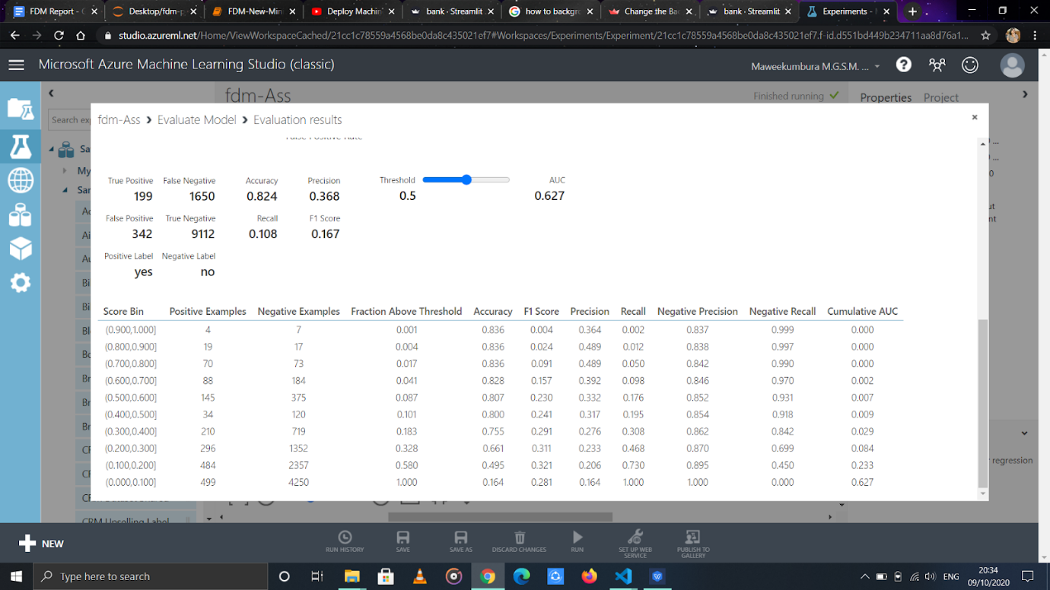

No of Features = 9

Accuracy =0.824

**Two-class Support Vector Machine**

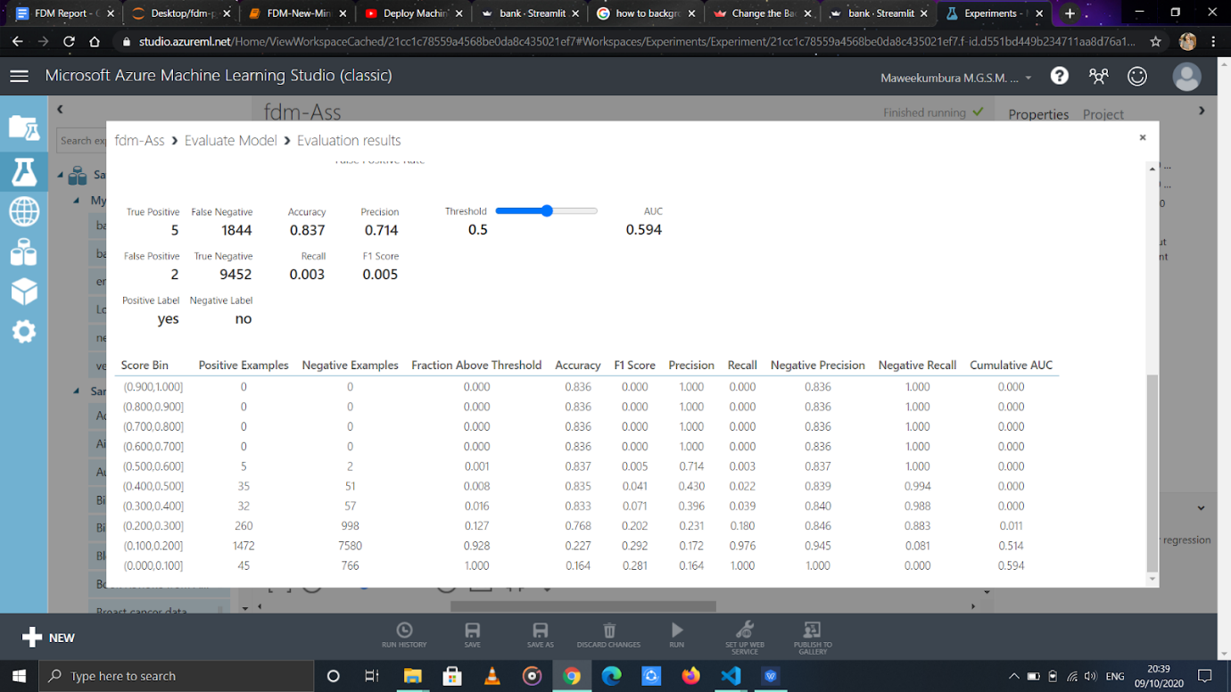

No of Features = 7

Accuracy =0.837

**Two-class Neural Network**

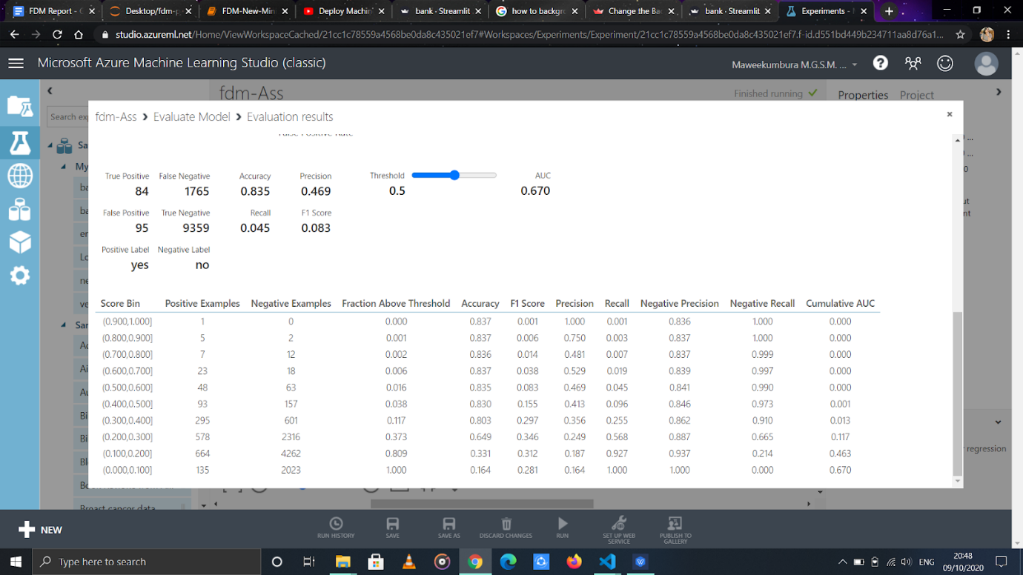

No of Features = 7

Accuracy =0.835

After doing the analysis, it was concluded that the highest accuracy was obtained when 6 variables were used. They are :

Job, personal loan, month of contact, education, if he has credit in default, balance in savings account

## Cleaning dataset

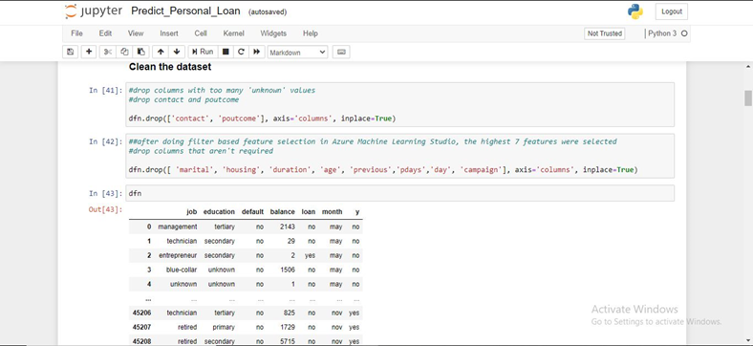

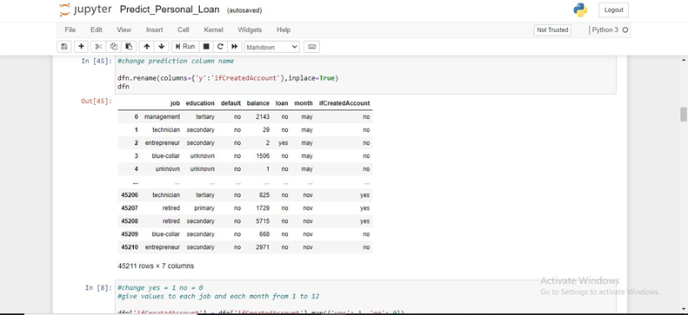

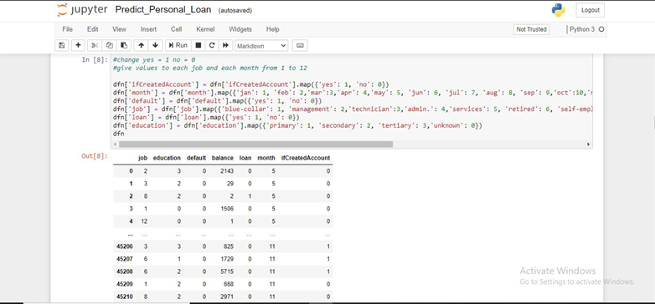

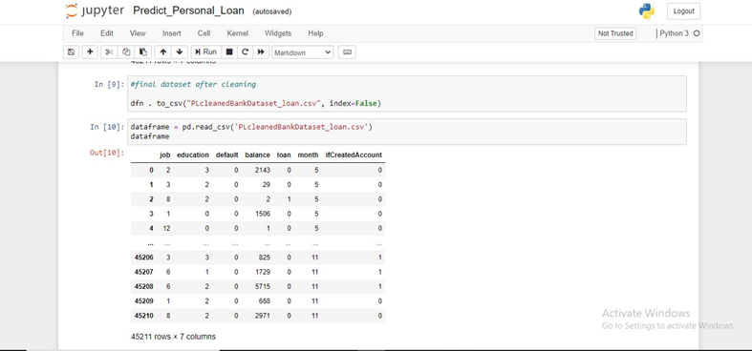

**Split data**

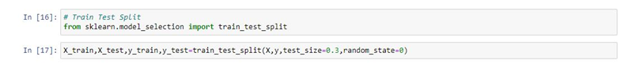

## Creating Models

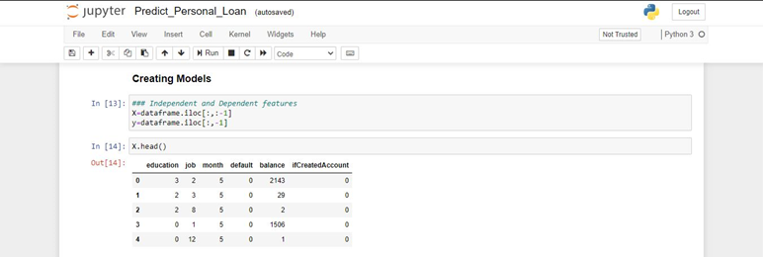

## Models Accuracy

**Random Forest**

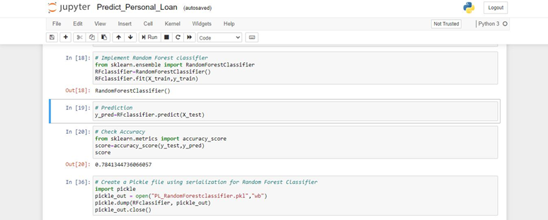

**Gaussian Naive Bayes classifier**

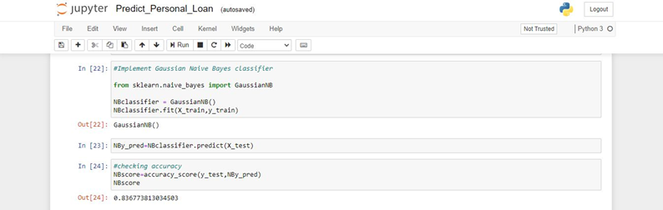

**Decision Tree classifier**

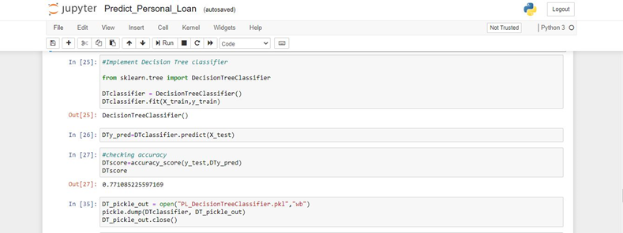

**KNeighborsClassifier**

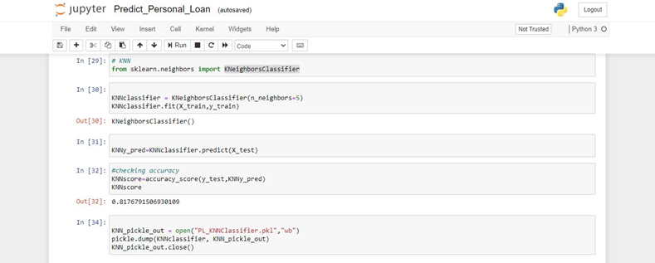

## Analysing data using graphs

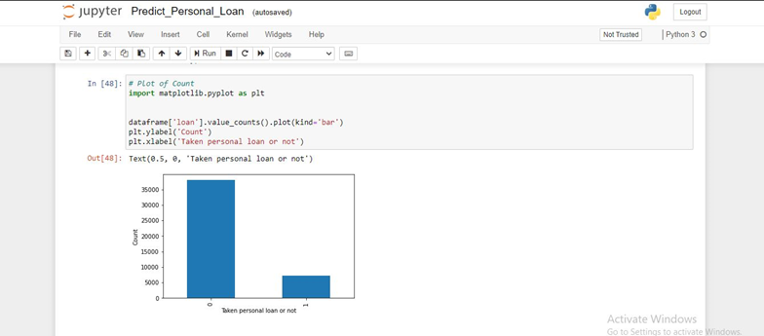

**Scatter plot**

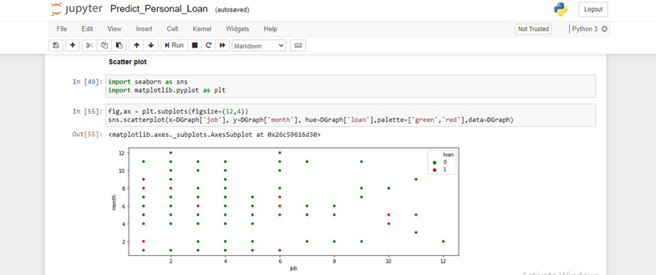

#### Bar charts

Comparing Education With the Personal Loan

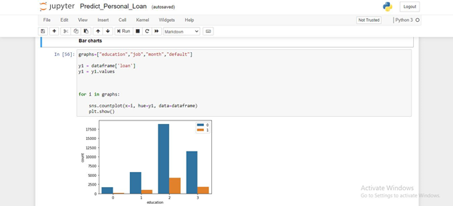

Comparing Job With the Personal Loan

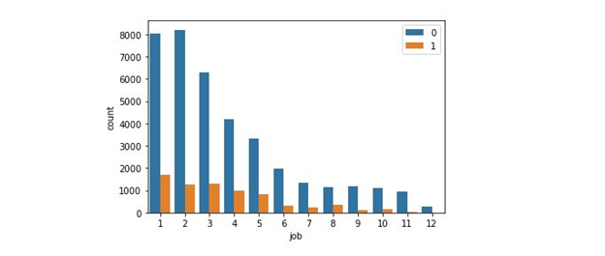

Comparing Month With the Personal Loan

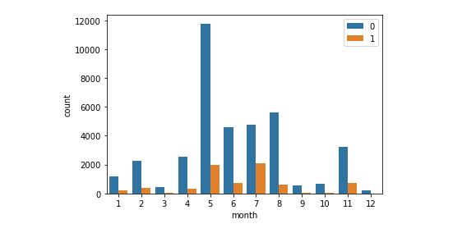

Comparing Default column With the Personal Loan

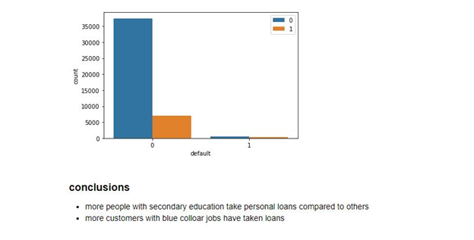

## Conclusions:

+ more people with secondary education take personal loans compared to others

+ more customers with blue collar jobs have taken loans

# User Interfaces

## Home page

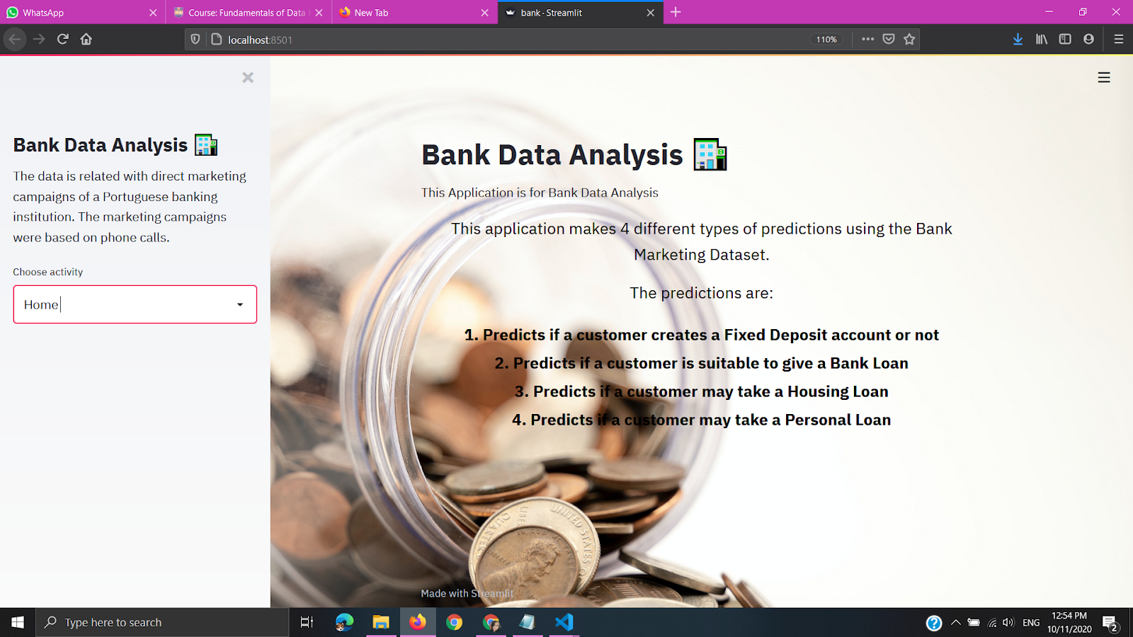

## 2. Visualize data page

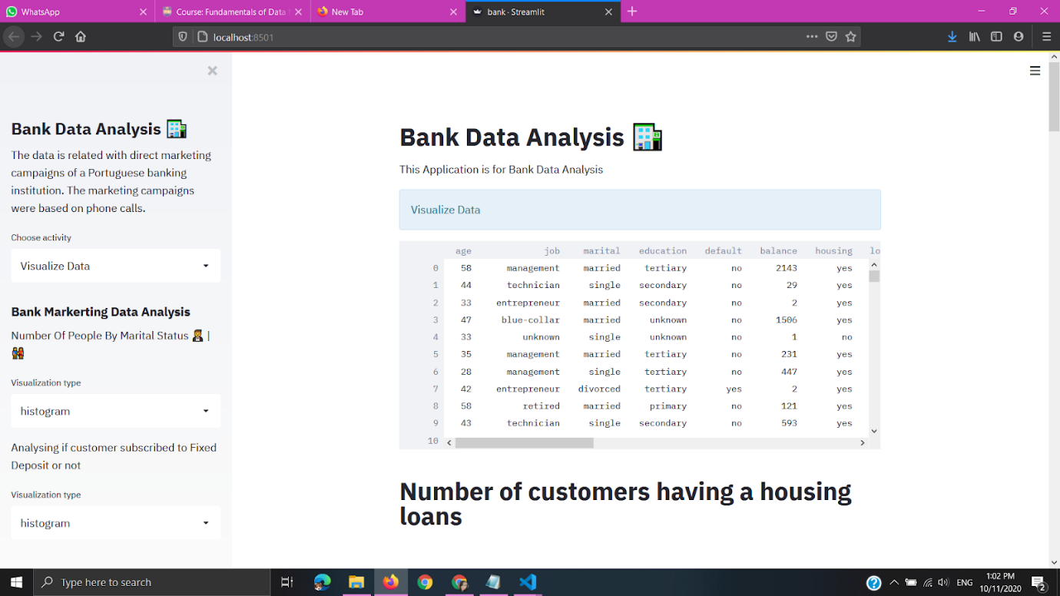

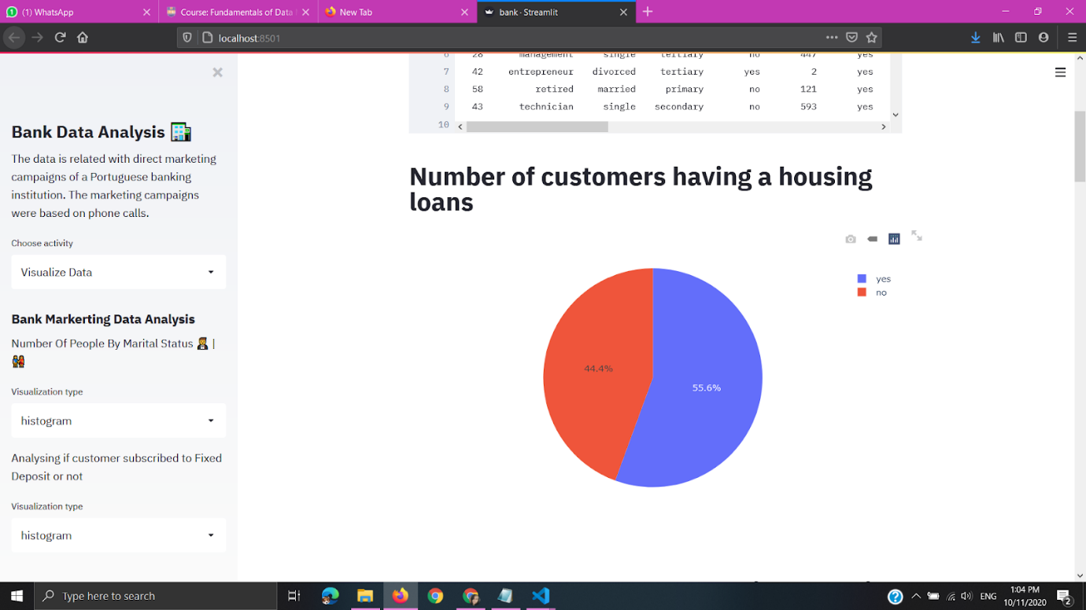

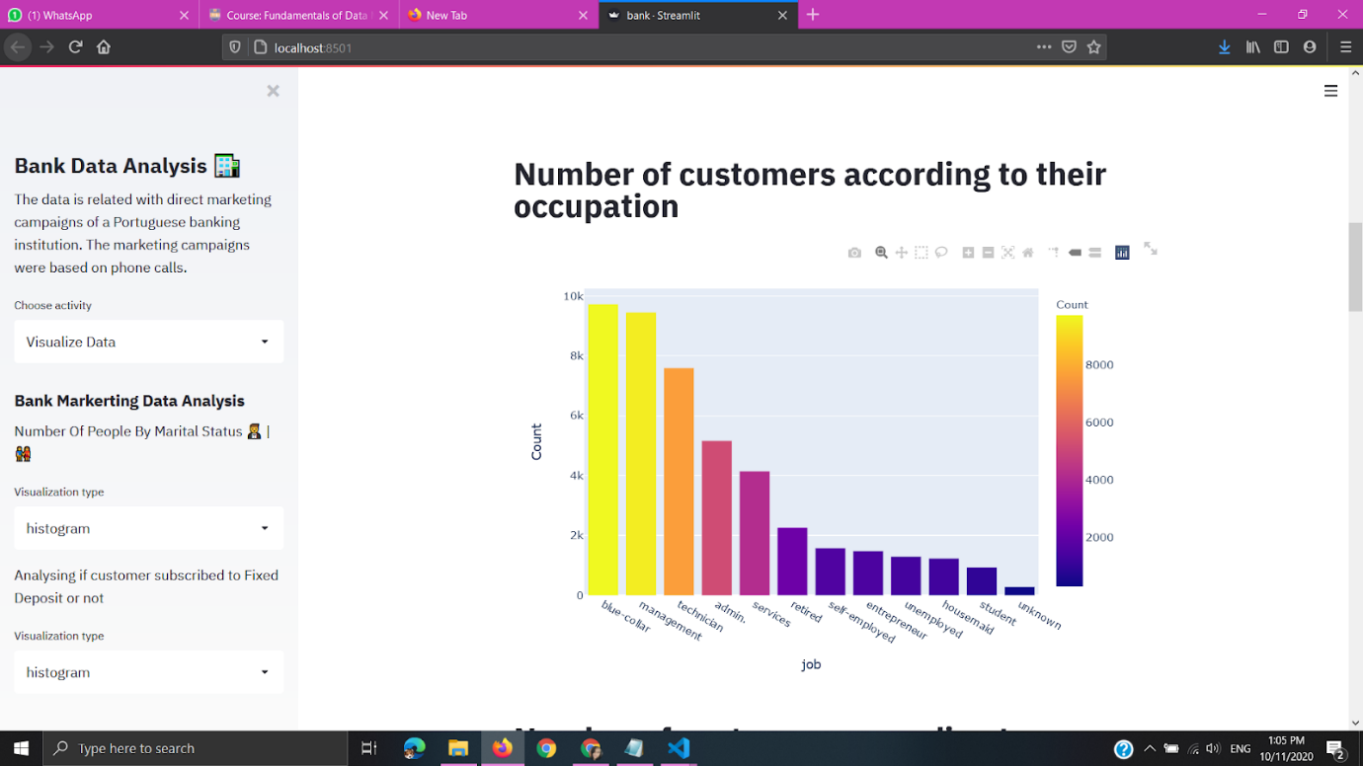

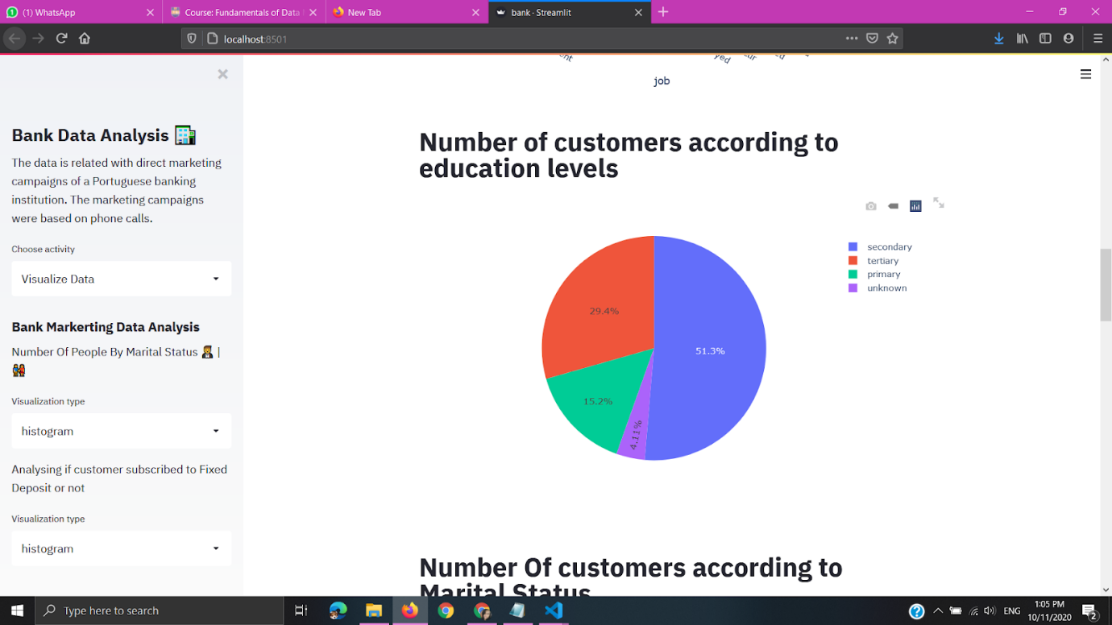

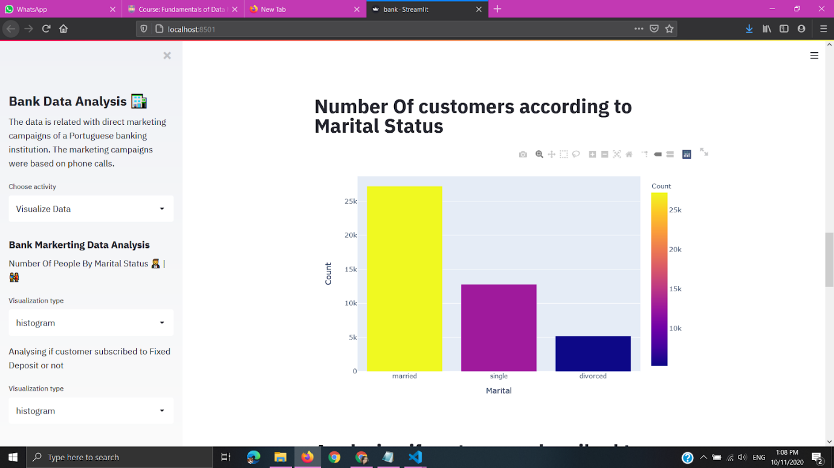

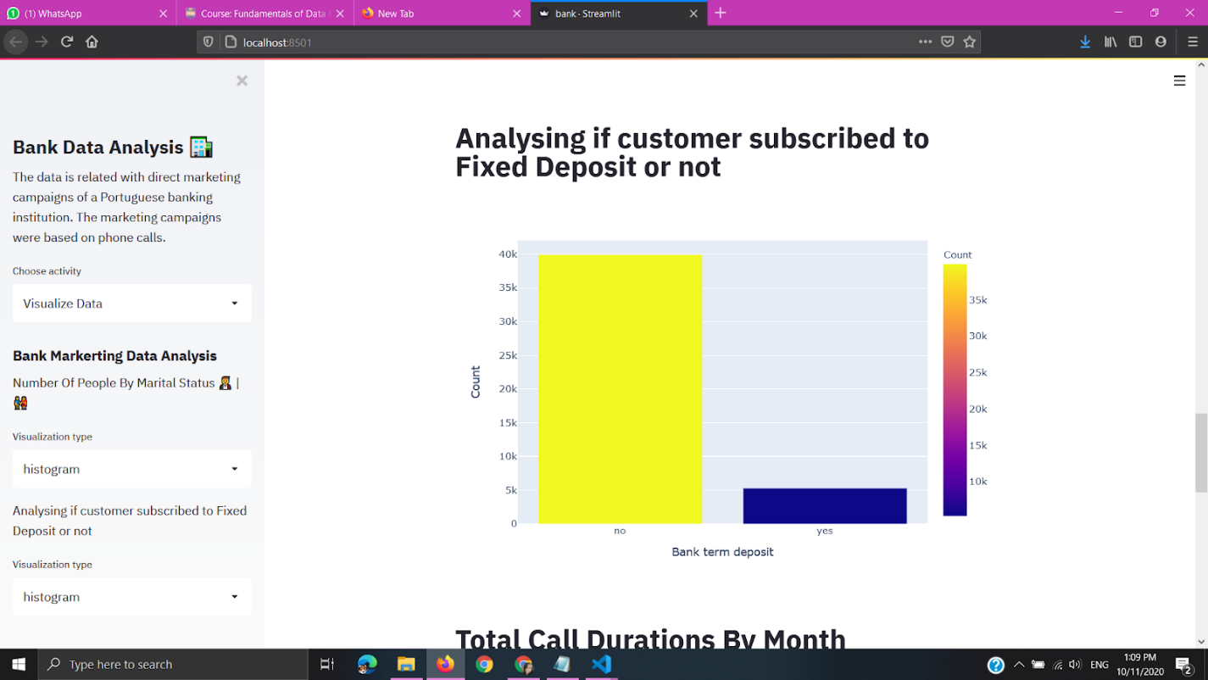

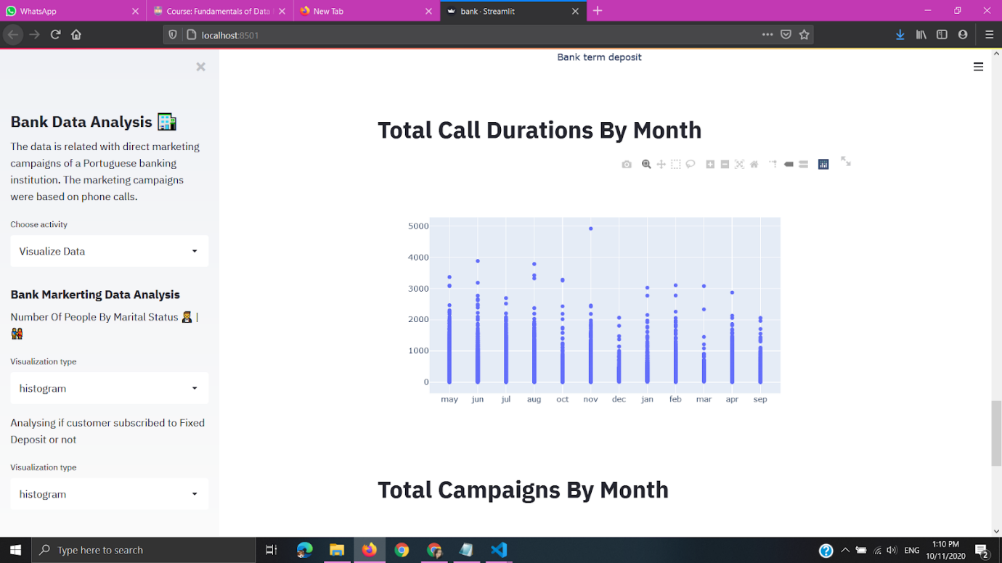

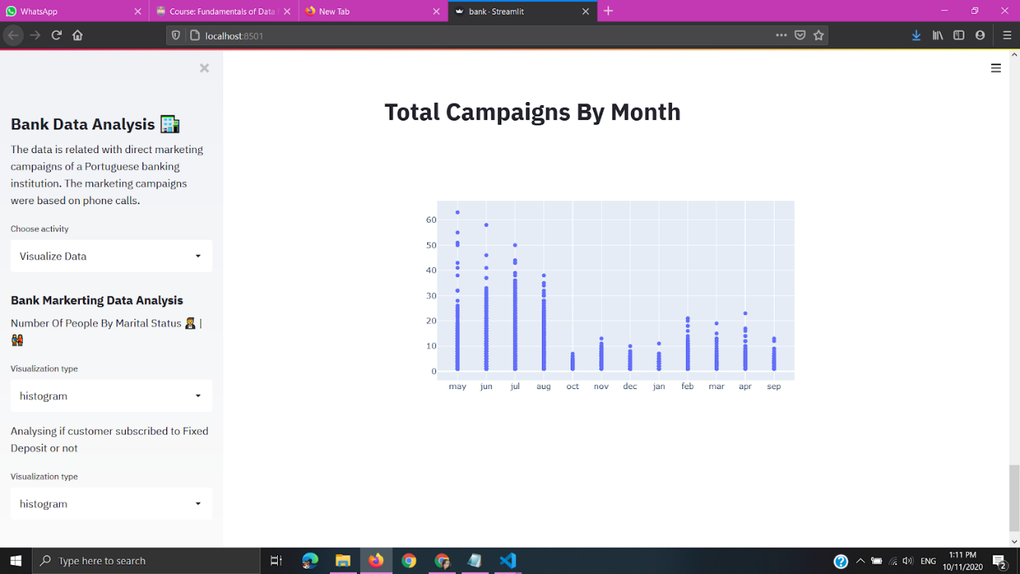

## 3. Predict fixed deposit creation

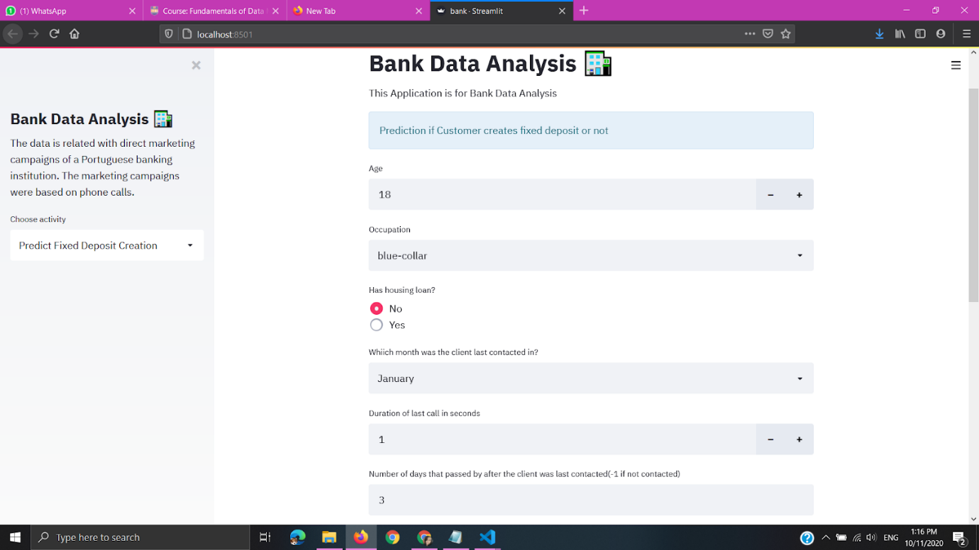

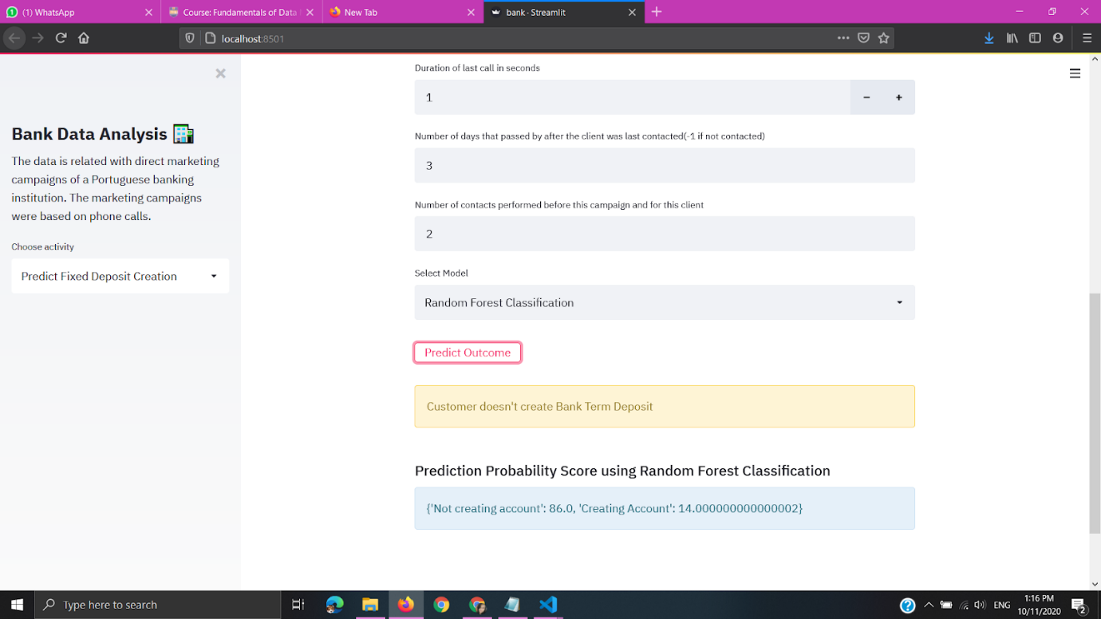

## 4.Loan Granting

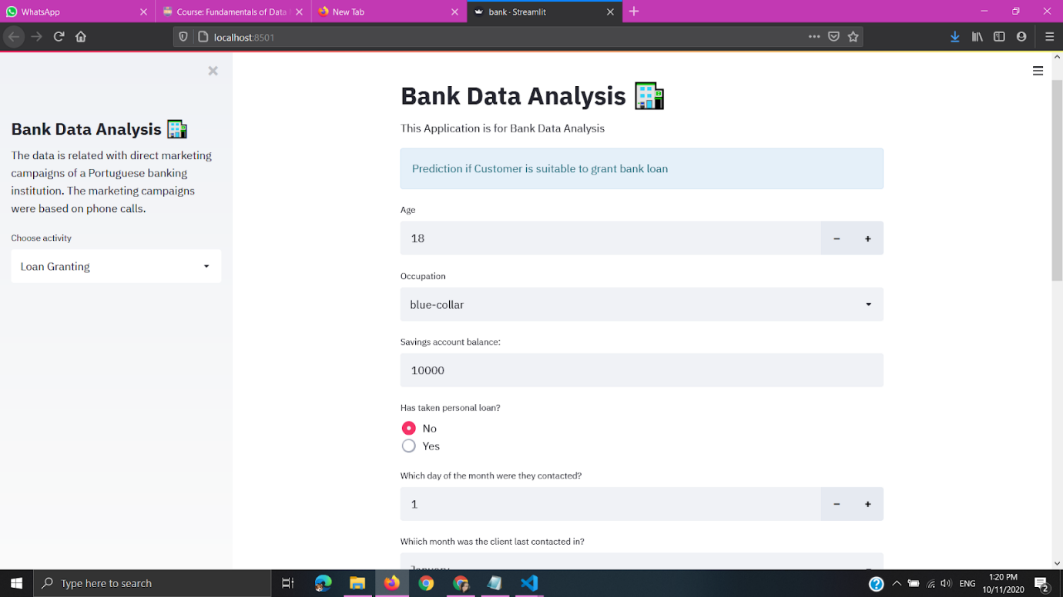

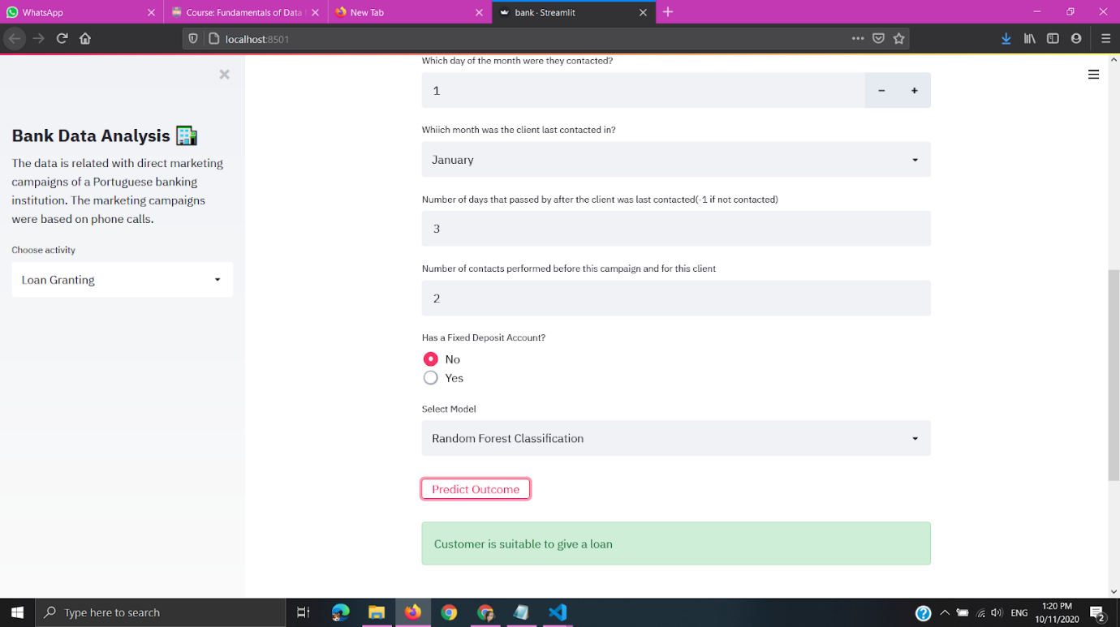

## 5. Predict housing loan necessity

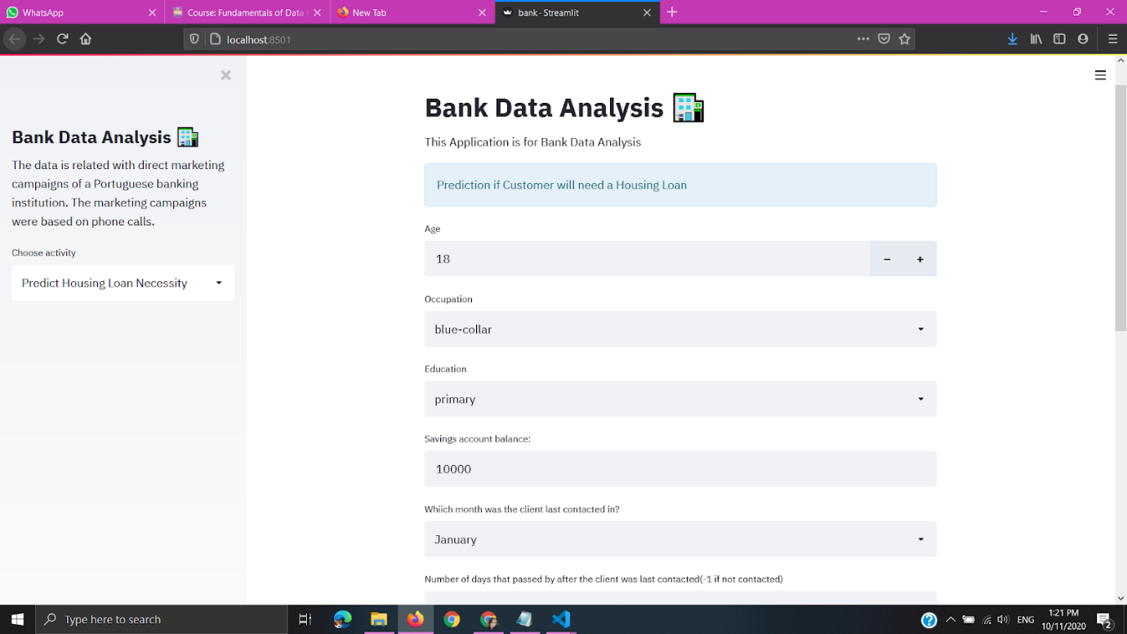

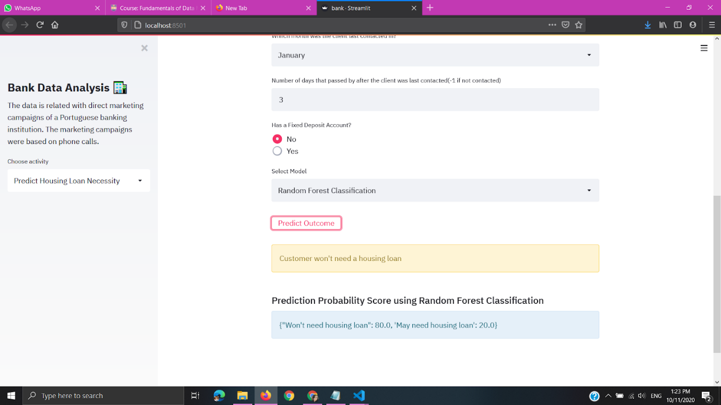

## 6.Predict personal loan necessity

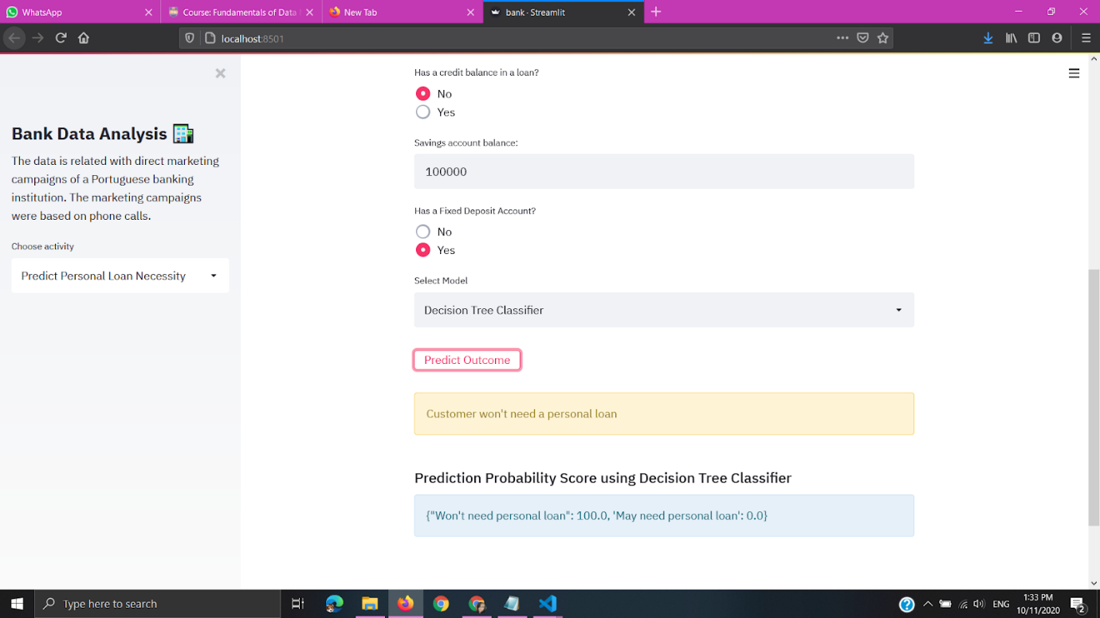

# Report Conclusion

* This application will be very important for banks as they can save a lot of time and money which is spent for advertising, as they can directly identify target customers.
* They can also identify the trends that are there and the co-relation between different features of their customers and the product or service they are promoting.
* This application is very important for marketing managers to organize future campaigns of the bank as well.
* The application will be beneficial to the managers who have to approve loans, as we are analysing if the customer will have a high chance of paying back the loan or not. It saves a lot of hassle for the banking institutions.
* It is very versatile and any banking institution can use this application to make predictions.